The Boston Globe
As Mass. considers generational ban on nicotine sales, what’s been Brookline’s experience?
By Stella Tannenbaum Globe Correspondent, Updated May 6, 2025, 4:06 a.m.
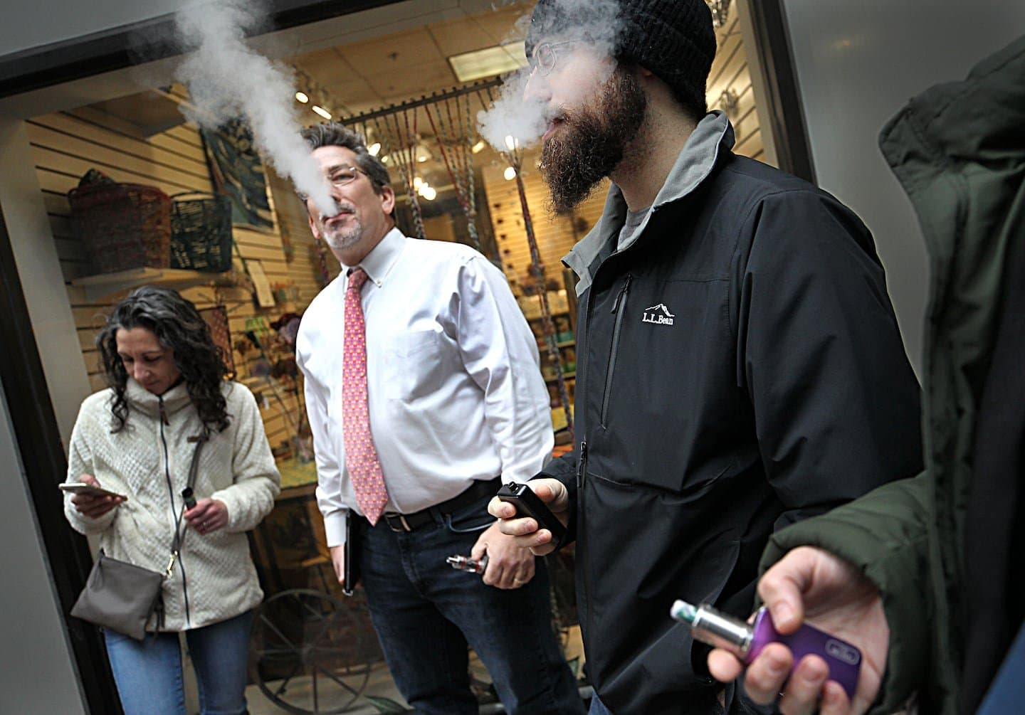Outside a 2019 public hearing on then-Governor Charlie Baker's ban on selling vaping products, consumers who opposed the ban vaped nicotine.
Suzanne Kreiter/Globe staff
Elias Audy is an unlikely proponent of a statewide ban on nicotine sales for young adults.
The gas station owner joined other Brookline tobacco retailers in suing to stop such a measure there, after the town in 2020 became the first in the nation to pass a lifetime ban on selling tobacco products to anyone born since the start of 2000.
Audy says cigarette sales at his store, Village Mobil, have been nearly halved and gas sales have fallen about 10 percent as drivers have gone elsewhere for their “one-stop shop.” Even so, he said he supports the statewide version of the policy now being considered by the Massachusetts Legislature.
“This way, you’re getting everyone on the same level playing field,” he said.
Massachusetts, which has long been at the forefront of tobacco restrictions nationally, is debating a statewide generational ban on tobacco sales, which could have potentially dramatic implications for both public health and businesses.
Since the Massachusetts Supreme Judicial Court dismissed the tobacco sellers’ lawsuit in March 2024, upholding Brookline’s policy, over a dozen other cities and towns have adopted similar ones. Now, the Legislature is considering a bill prohibiting anyone born on or after Jan. 1, 2006 — who are around 19 or younger today — from buying such products in the state.
Though experts say it’s too early to gauge the public health impact of the policy in Brookline, champions of the bylaw say they believe if such a ban takes effect statewide, it could prevent future generations from suffering tobacco-related cancers and nicotine addiction. And retailers like Audy in municipalities with generational bans say statewide adoption is more equitable.
“From a purely public health standpoint, there’s no safe use of tobacco and nicotine products,” said Sigalle Reiss, Brookline’s public health director, adding: “We’re creating a generation that won’t have to say, ‘I wish I never started.’”
Critics say such bans are bad for businesses and send young people seeking tobacco across state lines or into an underground, unregulated market where no one checks IDs. And while a statewide ban might level the playing field for many businesses, retailers along state borders could lose customers.
The statewide bill‘s sponsor, state Senator Jason Lewis, said store owners always “tell us that the sky is falling and that they can’t survive” when restrictions on nicotine sales are considered, but the businesses have since remained afloat.
If the bill passes, the population businesses can legally sell nicotine products to will decline gradually as people age, “so there will be plenty of time for retailers to be able to adjust to this new law should it pass,” said Lewis, a Winchester Democrat.
The number of tobacco sellers in Brookline has decreased to 16 from 18 since the ban passed in 2020, but both retailers who returned tobacco permits — one being Stop & Shop — cited their commitment to community wellness, not business pressures, Reiss said.
A Green Line train passes through Coolidge Corner in Brookline in 2023.
Craig F. Walker/Globe Staff
In Brookline, customers get frustrated with the restrictions “almost on a daily basis,” Audy said, adding that he nearly called the police on a customer in his 20s who became agitated when denied the chance to buy cigarettes.
Aaron Mehta, owner of Wine Press in Brookline and Fenway, said he was initially open to Brookline’s measure but now has “mixed feelings” because of logistical challenges.
“Five years from now, you’re going to be ID-ing people that are 30, that can buy alcohol, that can’t buy cigarettes, and it’s going to create a very confusing dynamic” for staff and customers, he said.
It’s too soon to discern the bylaw’s public health impacts despite five years having passed, said Katharine B. Silbaugh, a Boston University law professor who cosponsored the Brookline bylaw. She said she expected to see gradual results, as no products were ripped off the shelves, and everyone who could legally purchase tobacco when it was enacted will remain able to do so throughout their lifetimes.
“It’s a feature, not a bug, of the regulatory design,” Silbaugh said.
Still, there are signs that Brookline’s ban may have made a difference.
Three percent of Brookline High School students reported using tobacco products in the past month in 2023, a survey showed, down from 5 percent in 2015 and 10 percent in 2013, past surveys show. However, 9 percent of students in 2023 reported vaping in the past month, opting for a relatively newer product that can deliver either marijuana or nicotine.
Phasing out the ability for friends or older siblings to purchase tobacco for teenagers eliminates a main source of these products, said Matt DuBois, senior director of clinical services and social and emotional learning at the Public Schools of Brookline.
Proponents of the generational sales bans also point to the success of other recent restrictions cutting youth usage rates.
When Needham in 2005 became the first town in the country to raise the minimum tobacco purchasing age to 21, smoking initiation rates dramatically fell — even while the age was still 18 in neighboring towns, Silbaugh said, citing a study on the change. The statewide ban on stores selling flavored tobacco products took effect in 2020, and youth tobacco use rates in Massachusetts decreased to 18.4 percent in 2021 from 35 percent in 2019.
To Peter Brennan, executive director of the New England Convenience Store & Energy Marketers Association, which represents tobacco retailers, the flavor ban tells a different story. Brennan cited state public health survey data showing that about 37 percent of smokers reported using menthol cigarettes in 2022 — roughly the same proportion as in 2019, suggesting people are crossing state lines or purchasing them illegally. He anticipates something similar occurring if the statewide bill passes and nicotine and tobacco sales are eventually phased out altogether, with black-market dealers emerging.
“People are going to come to fill that void, and there‘s going to be profit to be had,” Brennan said. “And these products will be more widely available, just not in our stores, where we actually check IDs and make sure that kids aren’t buying them.”
Three percent of Brookline High School students reported using tobacco products in the past month in 2023, a survey showed, down from 5 percent in 2015 and 10 percent in 2013.Lane Turner/Globe Staff
Lewis said these concerns are common arguments in opposition to Massachusetts policies that differ from those of its neighbors. While “none of these policies are perfect,” he said, data show that other statewide tobacco restrictions have helped reduce tobacco use.
About 10 percent of adults said they used tobacco in 2023, down from over 13 percent in 2018, state surveys show.
Ginger O., a 19-year-old Boston resident who spoke on condition of not fully identifying herself to avoid career repercussions, said she vapes nicotine daily. She said she purchases at a local retailer who does not ask her for identification and still sells flavored products despite the ban. If Massachusetts adopts the generational ban, she wouldn’t be impacted personally because she was born before the cutoff. While it might be a successful deterrent, she said, those who want to access the products would still find a way.
“I don’t think it’s a bad idea, I just don’t know how well it will work,” she said, adding: “It’s not hard to get certain products or certain prices here, if you really want to.”
Meanwhile, Reiss, Brookline’s health chief, said enforcement of the generational ban has gone relatively smoothly.
When the town sent underage shoppers undercover to 18 stores in 2022, four shops sold tobacco products to the buyers. Brookline fined them each $300. The next two times the town did that, there were zero underage sales, Reiss said.
“In order to have successful policies, we need to engage with the regulated community,” she said. ”There‘s probably mixed feelings about the policy out there, but making sure that they understand it before we go out and start enforcing ... that’s a key strategy for me.”

Stella Tannenbaum can be reached at stella.tannenbaum@globe.com.

