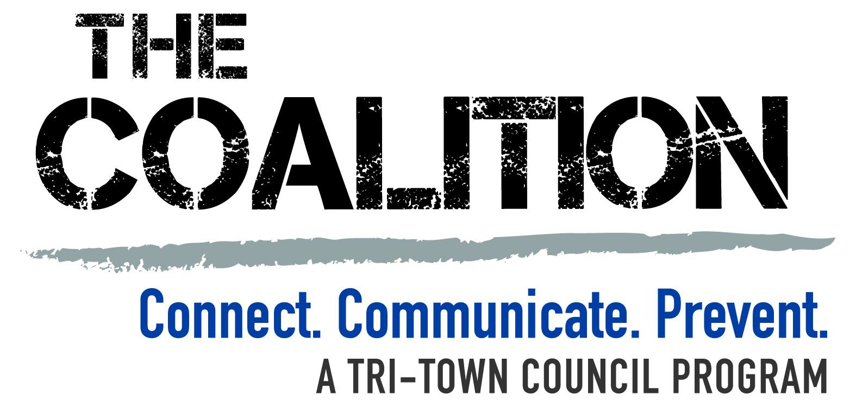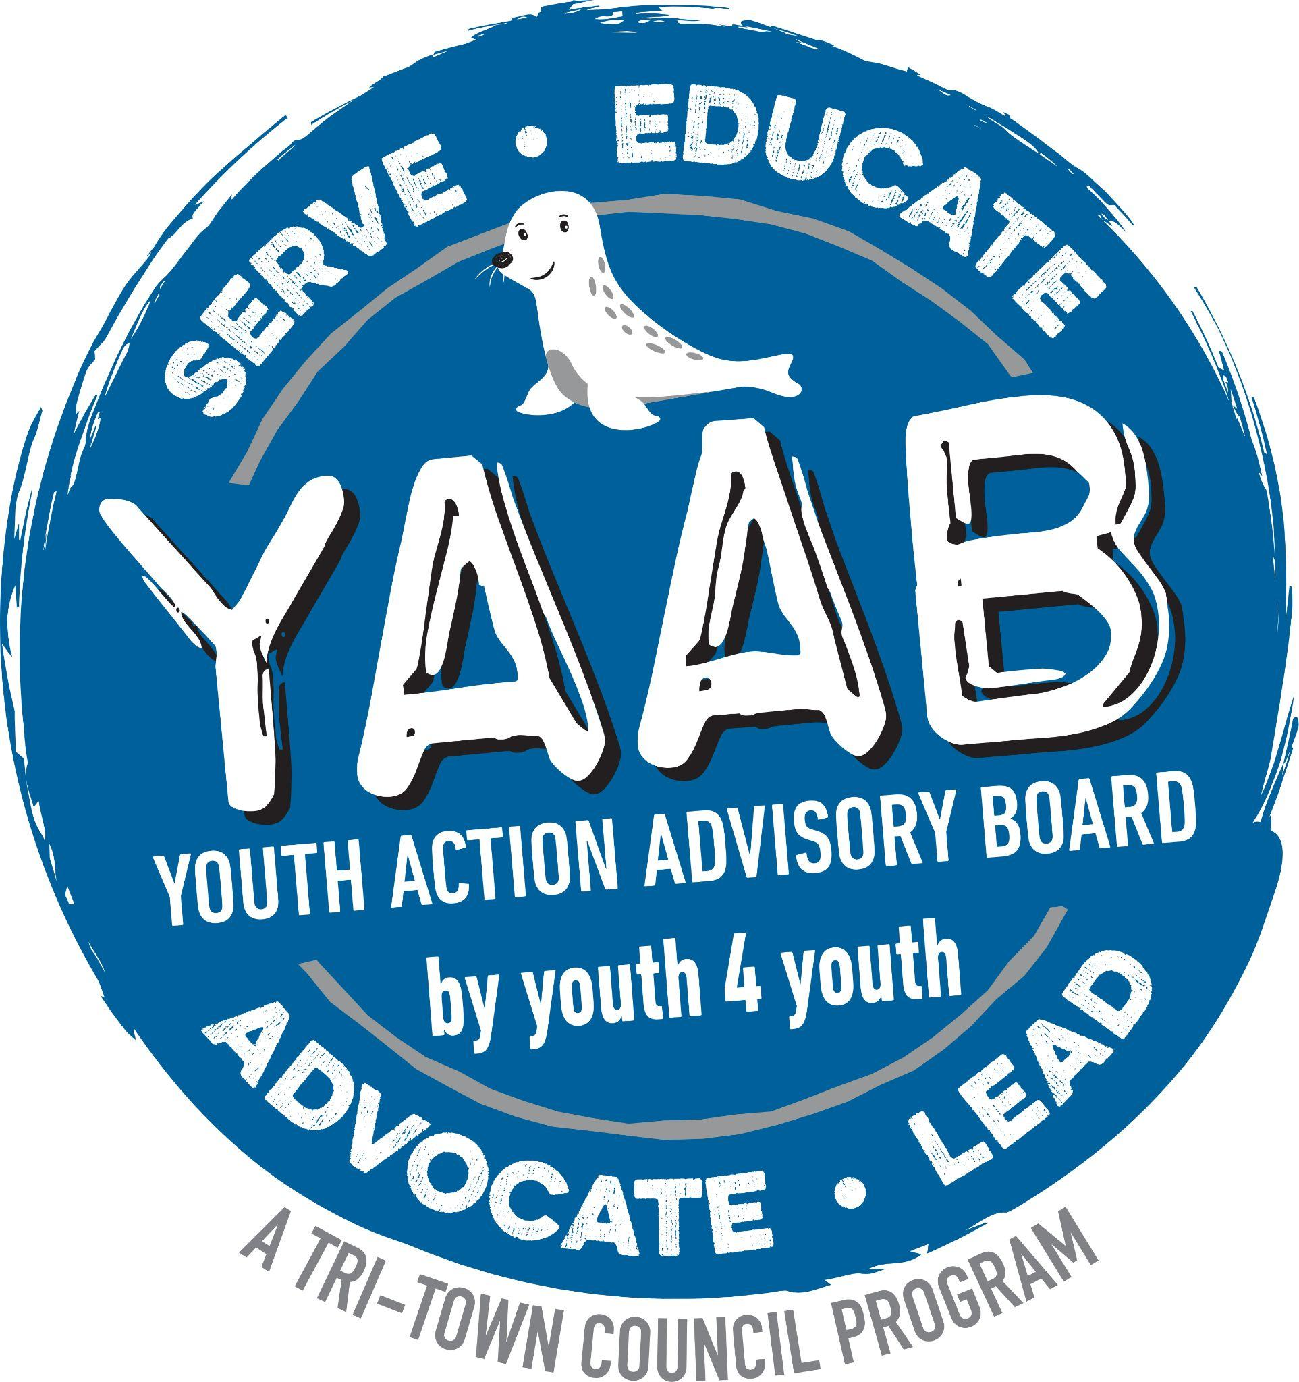

April 29, 2025

Dear Topsfield Board of Health,

We are writing to ask the Board of Health to consider adopting the Nicotine Free Generation policy in Topsfield. It is a forward-thinking approach that aims to protect our young people and aligns with Tri-Town Council’s Coalition’s mission of preventing and reducing youth substance use. By stopping nicotine products from being available for sale to future generations, we reduce youth access and prevent nicotine addiction from occurring. Surrounding towns’ Boards of Health - Reading, Melrose, Stoneham, Wakefield and Winchester - have enacted this policy.

In an article that appeared in the New England Journal of Health in May 2024, “nicotine is thought to be more addictive than other widely available products, such as alcohol and cannabis.” Research shows that vape use can lead to nicotine addiction, negatively impacting brain development during crucial adolescent years, and poses risks to respiratory health. Historically, tobacco companies create nicotine marketing campaigns and products that target young people, making them enticing and difficult to deny. These products are widespread and often lower in price, increasing their appeal and accessibility to young people. Too, “adolescents are particularly affected by the smoking behaviors of young adults -- people just above the minimum age for purchasing tobacco products, who may serve as role models or buyers for younger users. Reducing the availability of nicotine to this young adult group may reduce its attractiveness to teenagers.” Adopting the Nicotine Free Generation policy is a vital step to protect Topsfield and neighboring Tri-Town youth from these risks and manipulative marketing practices.

Local Masconomet High School Youth Risk Behavior Survey (YRBS) data shows a continual decline in youth vaping rates since it was first measured in 2014, with a 17% drop from 2018 to 2021. The most recent YRBS data from 2023 again shows a continued decrease in Tri-Town high school youth vaping rates. What changed? More widespread education and awareness campaigns for youth and parents/caregivers; the implementation of a restriction on flavored nicotine products in Topsfield and Middleton and eventually Massachusetts; , and passing of state, and then national legislation, which raised the age to purchase tobacco to 21. Strong policy can make an impact!

Nicotine Free Generation highlights the continued need for prevention programs and policies to protect our youth from nicotine addiction. Adopting it in Topsfield sends a powerful message to our community, emphasizing our continued efforts to safeguard the health and future of our children, and empower them to live a healthy, nicotine-free life.

Sincerely,

Nicole Gregoire-Allis, Coalition Coordinator Hilary LaMotte Burke, DFC Project Director
and members of Tri-Town Council’s Coalition and Youth Action Advisory Board

New England Journal of Medicine, Katharine Silbaugh, JD. et al, Toward a Tobacco Free Generation - A Birth Date-Based Phaseout Approach,” Volume 390, p. 1837.
New England Journal of Medicine, Katharine Silbaugh, JD. et al, Toward a Tobacco Free Generation - A Birth Date-Based Phaseout Approach,” Volume 390, p. 1837.

