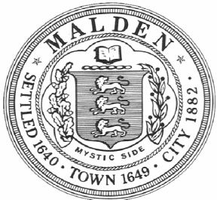 CITY OF MALDEN

Health Department / Board of Health

215 Pleasant St., 3nd Flr

Malden, MA 02148

781-397-7000 ext. 2049 (P)

Christopher Webb, Director

PUBLIC HEARING
Malden Board of Health
City Council Chamber
January 31, 2024
215 Pleasant St, 6:00PM

The Malden Board of Health will be conducting a Public Hearing on January 31, 2024, 6:00 PM, at Malden City Council Chambers, 215 Pleasant St, First Floor on Amendments to Section 21 of the Board of Health Rules and Regulations, Nicotine Delivery Systems, relative to;

“Prohibition of Sales – No person, firm, corporation, establishment, or agency shall sell tobacco or e-cigarette products to anyone born on or after 1/1/2004.

Any person, firm, corporation, establishment, or agency who or which shall violate any provisions of this regulation and upon written notification shall be fined and suspended in accordance to the schedule set forth under the Regulation of the Malden Board of Health Restricting the Sale of Tobacco Products.”

Prior to January 31, 2024 at 3:30 PM, persons may submit written commentary regarding
the proposed ordinance to the Malden Board of Health, City Hall, 215 Pleasant
Street, Third Floor, Malden, 02148. Attention: Chris Webb, or by e-mail at:
cwebb@cityofmalden.org

Following the public hearing, the Malden Board of Health will take up the consideration
of the proposed ordinance for purposes of adoption at the next scheduled Board of Health
meeting. While considering the proposed ordinance for adoption, the Malden Board of
Health may modify, amend or revise the ordinance.

