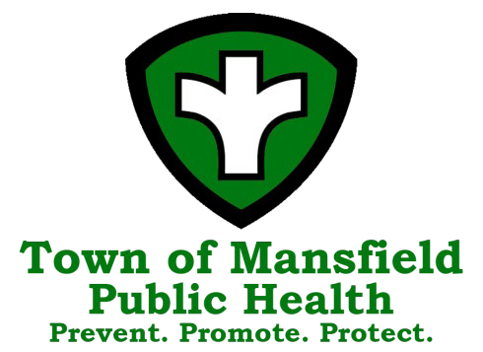
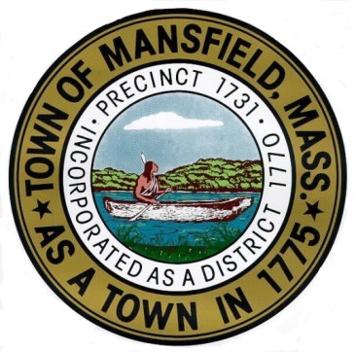
Town of Mansfield
Board of Health Agenda

April 10, 2025 – 7:00 PM

The mission of the Mansfield Board of Health is to protect, preserve and improve the public health, environment and wellbeing of our citizens through the enforcement of federal, state and local statutes and regulations, education and promotion of sanitary living and working conditions, and protection of the environment from disease and pollution.

7:00 PM Call to Order

7:01 PM Correspondence

7:05 PM Consent Agenda (Please see report at end of agenda)

7:10 PM Meeting Minutes
- March 13, 2025

7:15 PM Presentation on Bristol-Norfolk Public Health Partners Strategic Plan- BME Strategies

7:35 PM Tobacco Sales Regulations Discussion
    - Nicotine-Free Generation- Maureen Buzby, Regional Tobacco Prevention Program, Melrose
    - Inclusion of nicotine pouch restrictions

Tobacco Permit Increase Request – Asim Jamil

8:15 PM BOH Goals and Objective discussion- Communicable Disease Control and Chronic Disease & Injury Disease Prevention

8:35 PM March 2025 Public Health Nursing report & Infectious Disease Updates

8:40 PM Diversity Equity and Inclusion

8:45 PM Important Dates:
- Free Health Screenings including blood pressure, blood sugar, cholesterol, Hands only CPR and associated prevention information
  - 2nd Tuesday at the COA, 255 Hope Street, 9am-12pm
  - 3rd Wednesday at Town Hall, 6 Park Row, 9am-12pm
  - Recovery City, May 8th Town Hall, 6 Park Row, Room 3AB, 7pm
- MAHB Conference, May 10th in Marlborough

8:50 PM Department Updates
- Permitting
- Bristol-Norfolk Public Health Partners Coalition Grants Update
- Public Health Excellence Grant Program for Shared Services
- Local health support for COVID-19 Case Investigation and Contact Tracing
- PFAS
- Website/ Social Media Update
- Housing Inspections
- FOG
- Grants
  - FDA Retail Standards Grant

8:55 PM Visitor Comments

8:57 PM Items not known 48 hours prior

9:00 PM Adjournment

