Massachusetts Public Health Nurses attended and presented at the APHA annual conference in Washington D.C. (Nov. 2-5, 2025)
Submitted by: Glynnis LaRosa

The APHA annual conference was held in Washington D.C. this year. This year’s theme was “Making the Public's Health a National Priority”. Two MA public health nurses (PHNs) were on the APHA PHN Section’s Local Arrangements Committee this past year: Mary McKenzie and Glynnis LaRosa. Additionally, one of our retired PHNs, Elaine Silva also attended the conference and helped to staff the PHN Section Booth.
Glynnis was thrilled to see three of our western MA PHNs at the conference! They stopped by the PHN Section booth: Megan Tudryn Greenfield PHN and Saran Fiske.
Megan Tudryn, BSN, RN, PHN, CHO, RS; Linda Koh, PhD, MS, RN, PHN; and Sarah Fiske, PhD, RN, CNL presented a poster entitled “Public Health Nurses; Role in Dismantling Period Poverty and Supporting Menstrual Equity: A Scoping Review”. Glynnis stopped by to view their poster and hear about to their strong public health nursing research work (photo below).

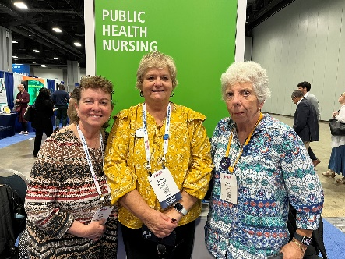

Glynnis, Elaine, and Mary


Glynnis and Megan Glynnis and Sarah

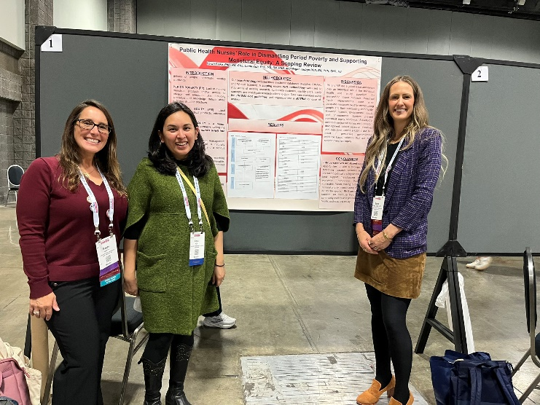
APHA PHN poster presentation: Megan Tudryn, BSN, RN, PHN, CHO, RS; Linda Koh, PhD, MS, RN, PHN; and Sarah Fiske, PhD, RN, CNL

