Dover Board of Health
All-Hazards Public Health Emergency Response Framework

Last Updated: [DATE]

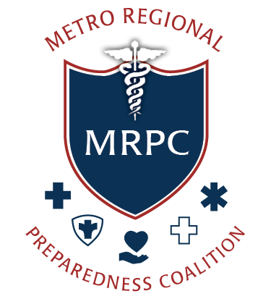

This plan was developed in coordination with the Region 4AB Public Health Emergency Preparedness (PHEP) Coalition with funding support by the PHEP Cooperative Agreement from the Centers for Disease Control and Prevention (CDC).

Table of Contents
Record of Changes 5
I. Overview 6
A. PURPOSE 6
B. SCOPE 7
C. SITUATION 7
D. HAZARD ANALYSIS 8
E. PLANNING ASSUMPTIONS 8
F. PLAN MAINTENANCE 10
II. Concept of Operations 11
A. OVERVIEW 11
B. OVERARCHING LOCAL PUBLIC HEALTH ROLE IN THE EMERGENCY MANAGEMENT CYCLE 12
C. ROLE OF THE MDPH REGION 4AB HEALTH & MEDICAL COORDINATING COALITION (HMCC) 14
D. ADDITIONAL RESPONSE PARTNER ROLES 16
E. SHARED SERVICE ARRANGEMENTS 17
III. Incident Management 18
A. INCIDENT RECOGNITION 18
B. ACTIVATION 18
C. DEPARTMENT OPERATIONS CENTER / EMERGENCY OPERATIONS CENTER 19
D. ACTIVATION LEVELS 19
E. DOC ACTIVATION NOTIFICATIONS 20
F. INCIDENT COMMAND SYSTEM 20
G. INITIAL RESPONSE 23
H. SUSTAINED RESPONSE 23
I. ISSUANCE OF LOCAL PUBLIC HEALTH ORDER 23
J. FINANCE AND ADMINISTRATION 24
K. DEACTIVATION/DEMOBILIZATION 26
IV. Information Management 28
A. INFORMATION MANAGEMENT 28
B. INFORMATION SHARING 30
C. EMERGENCY PUBLIC INFORMATION AND WARNING 32
V. Biosurveillance 34
A. PUBLIC HEALTH LABORATORY TESTING 34
B. PUBLIC HEALTH SURVEILLANCE 34
C. PUBLIC HEALTH EPIDEMIOLOGICAL INVESTIGATION 35
D. CONTACT TRACING 35
V. Countermeasures and Mitigation 36
A. MEDICAL COUNTERMEASURE DISPENSING AND ADMINISTRATION 36
B. MEDICAL MATERIEL MANAGEMENT AND DISTRIBUTION 37
C. NONPHARMACEUTICAL INTERVENTIONS 38
D. RESPONDER SAFETY AND HEALTH 42
VII. Surge Management 44
A. FATALITY MANAGEMENT 44
B. MASS CARE 45
C. MEDICAL SURGE 46
D. VOLUNTEER MANAGEMENT 47
EQUITY IN PUBLIC HEALTH RESPONSE 48
Appendix A 52
LOCAL PUBLIC HEALTH DECISION MATRIX 52
Appendix B 53
CONTACT LIST 53
Appendix C 54
MEMORANDUM OF AGREEMENT/UNDERSTANDING 54
Appendix D 55
RELEVANT LAWS AND REGULATIONS 55
State Government 57
Massachusetts Civil Defense Act 57
Local Government 57
Appendix E 59
CDC PUBLIC HEALTH EMERGENCY PREPAREDNESS AND RESPONSE CAPABILITIES 59
Appendix F 66
PUBLIC HEALTH ACCREDITATION BOARD (PHAB) REQUIREMENTS 66
Appendix G 69
MRC REGION 4AB REQUEST FOR ASSISTANCE 69
Appendix H 72
TEMPLATE INSTRUCTIONS 72

Record of Changes
The Massachusetts Region 4AB Public Health Emergency Preparedness (PHEP) Coalition developed and issued this plan as a template for customization and use by local Boards of Health and Health Departments. The Region 4AB PHEP Coalition will periodically review, update, and re-issue the template based on feedback from the Coalition and advances in practice.
The Dover Board of Health will review and update the plan annually. Changes to the plan are tracked below by documenting the date, name of the person who changed the document, and a brief description of the change. A new version number should be assigned when local changes are made to the plan (e.g., 1.2, 1.3) and when the Region 4AB PHEP Coalition revises the plan template (e.g. 2.0, 3.0). The record reflects any significant change made to the plan in the prior five years with the most recent change recorded at the top of the record. The revision date (footer) is updated following any change to the plan. When a significant change is made to the plan, the signatories must re-acknowledge their approval and the plan should be redistributed to the agencies listed in the Record of Distribution.
Version | Date | Name | Description
1.1 | 00/00/0000 | Insert Name, Insert Position | Plan customized to document local information and details.
1.0 | 12/1/2025 | Region 4AB PHEP Coalition | Release of plan template 1.0.

I. Overview
Massachusetts cities and towns, each with a local board of health and/or health department, must provide a comprehensive set of public health services as required by state law and Massachusetts Department of Public Health (MDPH) regulations. Local boards of health carry out many duties, including but not limited to:
Enforcing housing health standards
Enforcing lead poisoning regulations and sanitary code.

Enforcing tobacco control laws
Enforcing no-smoking and related regulations.

Preparing for emergencies
Developing, testing, and promoting awareness of emergency preparedness plans for a wide range of hazards.

Performing other health duties
Issuing burial permits, regulating pesticides, inspecting bodywork and tattoo parlors, and issuing health reports.

Protecting food supply
Inspections of restaurants and other food establishments.

Managing wastewater and solid waste
Permitting and inspection of septic systems, landfills, and other solid waste facilities.

Controlling disease and protecting workers
Reporting and responding to communicable diseases; addressing occupational health and safety violations, foodborne illness, and rabies.

Inspecting public places
Overseeing pools, beaches, camps, hotels, and mobile home parks.

This framework provides the Dover Board of Health with a foundational structure to prepare for, respond to, and recover from all-hazards public health emergencies.

A. PURPOSE

This plan explains Dover Board of Health’s roles and responsibilities to plan for, respond to, and recover from a wide range of public health emergencies and hazards. It also outlines key public health emergency response functions and tasks, as defined in local, state, and federal guidance.

B. SCOPE
This plan applies to the Dover Board of Health. It provides direction and guidance for incidents that impact or could impact the department and/or public health in Dover. The plan is flexible and scalable for emergencies of any type, size, and scope.
This plan does not replace the Dover Comprehensive Emergency Management Plan (CEMP). It supports the CEMP by detailing responsibilities for Emergency Support Function #8 (ESF-8) – Public Health and Medical Services.
This plan uses the Incident Command System (ICS) and the National Incident Management System (NIMS), which are national standards established under Homeland Security Presidential Directive 5 (HSPD-5) and Presidential Policy Directive 8 (PPD-8). It also aligns with the Centers for Disease Control and Prevention (CDC) Public Health Emergency Preparedness and Response Capabilities (see Appendix E) and the Public Health Accreditation Board (PHAB) Emergency Operations Plan (EOP) requirements (see Appendix F).

C. SITUATION
The Dover Board of Health serves the Town of Dover, located in Norfolk County in Massachusetts.
- Location: [Insert a brief description of the jurisdiction’s location within the region/state.]
- Population: According to the 2020 United States Census, the population of Dover is approximately [number], and includes [number] households.
- Community Profile: [Insert a brief description of the jurisdiction’s key demographics, primary languages spoken, and access and functional needs.]
- Critical Infrastructure: [Insert a brief description of the jurisdiction’s public health and healthcare infrastructure (e.g., hospital, long-term care facility, water treatment, etc.)]
- Geographic Features: [Insert a brief description of the jurisdiction’s geographic features that may affect emergencies (e.g., coastal, flood zones, major highways, etc.)]
- [Insert other local context as needed to explain factors that change local risk, resource needs, or response operations (e.g., college/university, seasonal tourism, major events, etc.).]

D. HAZARD ANALYSIS
The top hazards identified in the [assessment, date] for Dover are:
- Hazard 1
- Hazard 2
- Hazard 3
- Hazard 4
- Hazard 5

E. PLANNING ASSUMPTIONS

Roles and Responsibilities
- Dover Board of Health staff are familiar with this plan and understand their roles and responsibilities during an emergency.
- Effective response requires coordination with healthcare, human services, social services, emergency management, law enforcement, and other community partners.
- External partners develop and maintain their own emergency plans. This framework does not replace those plans.
Emergency Operations
- The Dover Board of Health will experience incidents that impact public health and the health system infrastructure.
- Under its legal authorities, Dover Board of Health:
  - Will implement necessary steps to protect the health of the residents of the Town of Dover;
  - Conduct epidemiological surveillance and investigations;
  - Issue public information and risk messages;
  - Support treatment and prophylaxis; and
  - Take actions to control disease and environmental hazards.
- When needed and allowed by state or local law, Dover Board of Health may implement measures to contain and control communicable disease or limit exposure to environmental hazards.
- Some emergencies may require the activation and dispensing of medical countermeasures.

Declarations of Emergency and Legal Authorities
- When warranted, the [Title of official with authority to declare a local state of emergency] may declare a local State of Emergency for the Town of Dover under Massachusetts General Laws.
- The [Title of official with authority to declare a local state of emergency] may order or recommend evacuations and/or shelter-in-place for residents and/or businesses.
- During a public health emergency, the [Title of Public Health Officer/Agent] and/or [Titles of other community officials designated by the community] may take actions to mitigate health impacts, save lives, protect property and the environment, and restore essential services and facilities. This may include issuing local public health orders.
- Some situations may require temporary legal or policy changes to maintain public health or healthcare services (e.g., licensure or regulatory waivers, Emergency Use Authorizations (EUAs)).
Information Sharing and Public Messaging
- During disasters, demand for health information and medical services increases.
- The Town of Dover uses established alert and warning systems to detect public health threats and to communicate with staff, partners, and the public.
- Leaders may need to make decisions with incomplete information and will update guidance as new facts become available.
- Communications will be clear, timely, and accessible for all audiences.
Response Resource Sharing
- The Dover Board of Health will first use its own staff, supplies, and equipment to respond to an emergency.
- When local resources are depleted (or nearly depleted), mutual aid may be requested from nearby communities and partners under existing Memorandums of Understanding (MOUs) and/or Mutual Aid Agreements (MAAs) (see Appendix C).
- Some emergencies may also impact neighboring jurisdictions, which can limit mutual aid availability. If local and partner resources are also depleted, the Dover Board of Health may request additional assistance through the local Emergency Management Director (EMD), the MDPH Region 4AB Health and Medical Coordinating Coalition (HMCC), the Massachusetts Department of Public Health (MDPH), and/or the Massachusetts Emergency Management Agency (MEMA).
- Routine public health activities that are not essential to the response (e.g., restaurant inspections) may be temporarily suspended during complex and/or extended emergencies. See the Continuity of Operations Plan (COOP) for more information.

F. PLAN MAINTENANCE

Dover Board of Health coordinates the development and maintenance of this plan. The plan will be updated when laws, policies, operations, or staffing change and after exercises or real events to incorporate lessons learned. All updates will be tracked in the plan’s Record of Changes. Each Division/Agency, staff member, and stakeholder with responsibilities assigned in the framework shall review the plan annually.

II. Concept of Operations

A. OVERVIEW

Under its legal authorities, Dover Board of Health will implement steps to protect the health of Town of Dover residents. Key actions include:
- Epidemiological surveillance and investigation
- Public information and risk communications
- Treatment and prophylaxis
- Disease mitigation and control actions
This section identifies the roles, responsibilities, and authority to respond to an incident that impacts public health.

When Public Health is the Lead Agency
Public Health may lead an emergency response when the emergency primarily impacts public health, including:
- Infectious disease outbreaks
- Environmental health emergencies
- Health-related shelter operations

When Public Health is a Supporting Agency
If another department has primary responsibility, Public Health provides health expertise and support. The lead agency may request a public health representative in the Emergency Operations Center (EOC). Example: In a major flood, the Emergency Management Director (EMD) may lead and request Public Health support for environmental health guidance, disease prevention recommendations, and health messaging coordination.

B. OVERARCHING LOCAL PUBLIC HEALTH ROLE IN THE EMERGENCY MANAGEMENT CYCLE

Prevention and Mitigation
- Conduct public health inspections at public sector facilities
- Coordinate immunization programs
- Coordinate with the EMD to identify community risks and hazards
- Provide public education on disease prevention and healthy behaviors

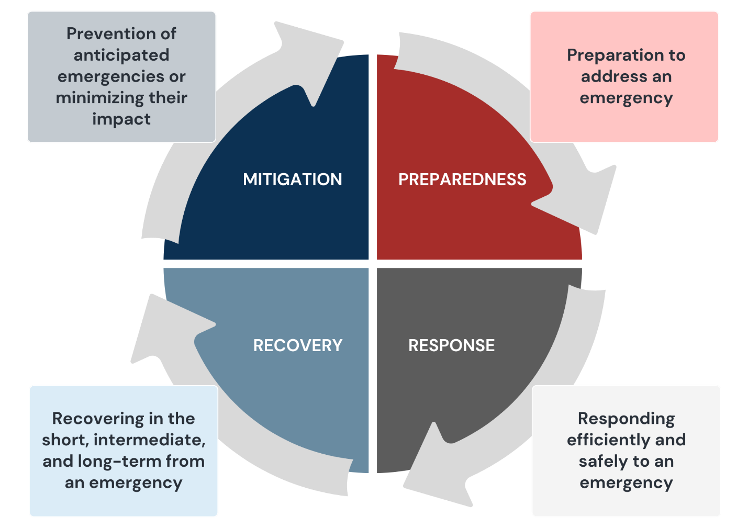
Preparedness
- Ensure public health staff assigned to the EOC are trained
- Maintain readiness of public health personnel, equipment, and supplies for disaster response
- Develop and update public health emergency plans and operating procedures
- Coordinate with healthcare facilities to ensure readiness of staff, equipment, and supplies
- Train staff in disease detection, evaluation and prevention
- Protect the community’s food and water supplies
- Coordinate health and medical planning with the EMD
- Coordinate pandemic planning with MDPH and local health partners
- Maintain plans for mass vaccination and medication dispensing
- Advise on control of disease vectors (e.g., insects, rodents)
- Recruit, train, and activate the Medical Reserve Corps (MRC)
- Coordinate with the EMD to plan support for individuals with access and functional needs

Response
- Provide trained EOC representative(s) to coordinate public health and medical resources
- Monitor the status of public health and healthcare facilities
- Coordinate with the water/sewer department to address potential contamination
- Investigate and correct sanitation problems during disasters
- Ensure safe waste disposal, food and water testing, and pest and vector control as needed
- Coordinate with the Chief Medical Examiner on mortuary services, including temporary morgues and victim identification
- Identify and address health hazards in affected areas
- With MDPH authorization, implement isolation and quarantine measures
- Issues health advisories to inform the public and partners
- Activate and manage Emergency Dispensing Sites (EDSs) for medical countermeasures
- Monitor food safety and sanitation in emergency shelters and mass care facilities
- Coordinate testing of diseased animals
- Advise on biohazards, hazardous materials, and radiological materials
- Liaises with state and federal health and environmental agencies
- Coordinate with the EMD to provide transportation services for individuals with access and functions needs
MANAGEMENT CYCLE, continued
Recovery
- Coordinate with the EMD to assess damages and public health impacts
- Coordinate with the debris management agencies to identify, prioritize, and safely remove debris that poses health risks (e.g., medical waste, asbestos, chemicals, mold)

C. ROLE OF THE MDPH REGION 4AB HEALTH & MEDICAL COORDINATING COALITION (HMCC)

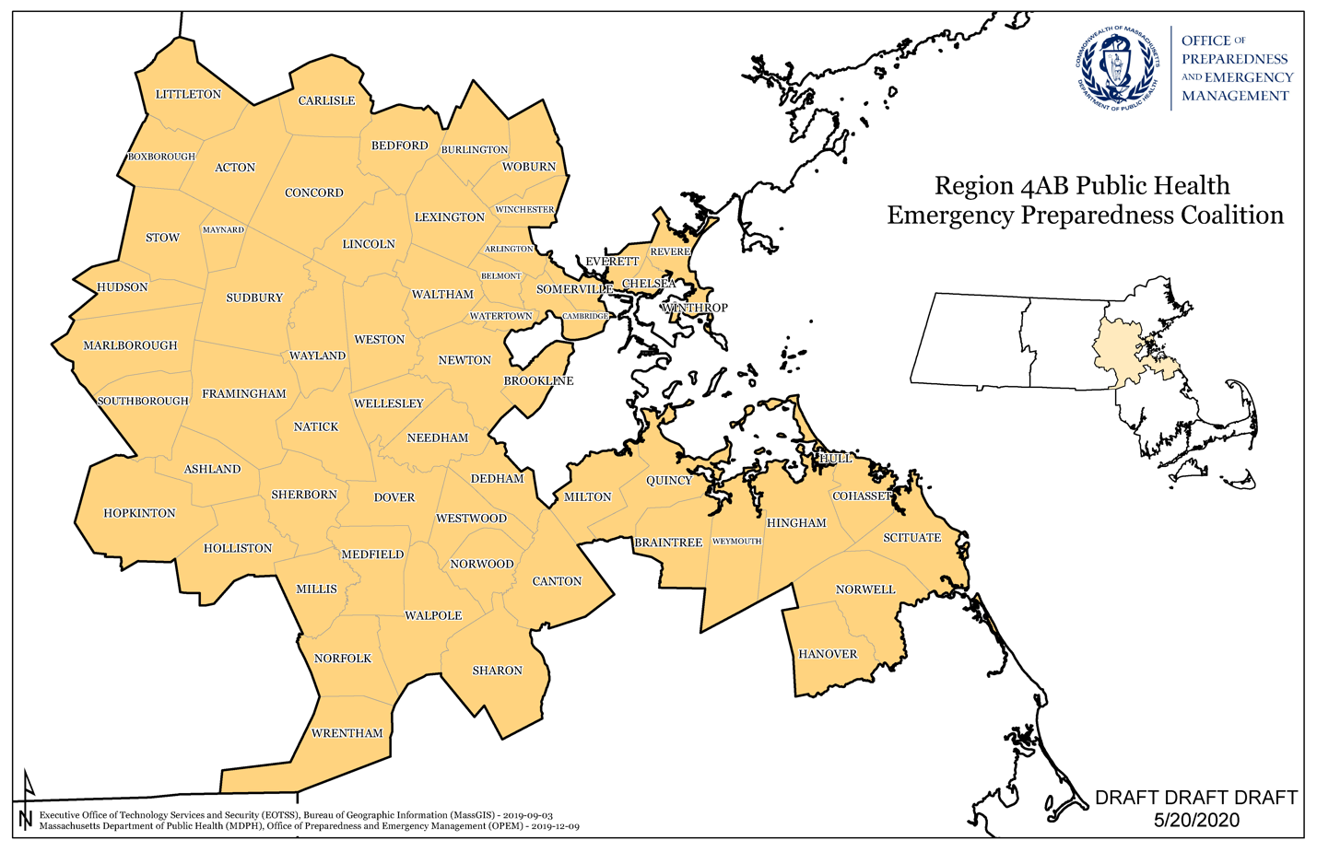
Massachusetts has six regional HMCCs that support cross-disciplinary planning and emergency response across public health and healthcare sectors. The Region 4AB HMCC, also known as the Metro Regional Preparedness Coalition (MRPC), is sponsored by the Cambridge Health Alliance (CHA). It serves 60 communities and 13 hospitals across five counties (Middlesex, Norfolk, Plymouth, Suffolk, and Worcester) covering the Metro-Boston and Metro-West areas.
The MRPC’s mission is “to enhance regional health and medical readiness for emergency events through collaborative, multidisciplinary planning necessary to foster a coordinated and effective regional response.”

During emergencies, the MRPC helps maintain a common operating picture through shared information and supports resource management across local and regional partners, especially within the healthcare system.

Key roles of the MRPC include:

- Collect and share essential elements of information (EEIs) to support situational awareness.

- Coordinate resource requests during incidents.

- Support recovery operations following emergencies.

- Conduct after-action reviews and develop improvement plans.
- Coordinate with local, regional, and state partners in public health, healthcare, and emergency management.

- Provide technical assistance for multi-agency coordination, incident management, and resource sharing.

- Participate in regional health and medical risk assessments, mitigation activities, training, and exercises.

- Maintain a regional resource inventory.

For more details, refer to the current Massachusetts Region 4AB, Metro Regional Preparedness Coalition (MRPC), Health and Medical Coordination Coalition (HMCC) Response Plan.

D. ADDITIONAL RESPONSE PARTNER ROLES

Level of Support | Partner Organization | Response Roles
Local | Emergency Management Director (EMD) | Lead or support local incident command; operate incident support facilities (e.g., EOC); coordinate resource requests and purchasing; support information sharing and public messaging; ensure that the needs of at-risk populations are addressed.
Local | Other Local Government Departments | Carry out assigned tasks to support public health emergency response; maintain their own response plans and procedures and share them with the LBOH and EMD.
Local | Non-Governmental Health Partners (hospitals, long-term care, behavioral health, community health centers) | Support predefined roles during a public health emergency (e.g., ESF-8, sheltering, mass care); share response plans and procedures with the LBOH and EMD.
Local | Other Community Partners (utilities, colleges, K-12 schools, community-based organizations) | Provide support to meet specific objectives (e.g., continuity of services, facilities, volunteers, outreach).
Regional | HMCC (Region 4AB/MRPC) | Provide ESF #8 technical assistance; help coordinate resource requests; liaise with state partners; assist with Medical Reserve Corps (MRC) activation; offer operational support for complex or extended responses.
Regional | Hazardous Materials (HAZMAT) Emergency Response Division | Identify hazardous substances; contain and mitigate spills or exposures; conduct decontamination; provide technical expertise, environmental sampling, and risk assessment; coordinate with state agencies.
State | MDPH | Provide policy guidance and subject matter expertise; provide staffing and coordination support when local resources are strained.
State | MEMA | Support local emergency management with ICS and EOC guidance; help coordinate local ESF-8 resource requests; assist with FEMA cost recovery assistance requests (when applicable).

E. SHARED SERVICE ARRANGEMENTS

The MDPH Office of Local and Regional Health Public Health Excellence (PHE) Grant Program funds Shared Service Arrangements, where cities and towns share staff, resources, and services to strengthen local public health regardless of community size or budget.

Shared public health services for Dover:
- Participating communities: [List cities/towns]
- Lead/host agency: [Name]
- Shared services: [e.g., inspections, epidemiology, nursing, health education, date/reporting, emergency preparedness]
- Points of contact: [Role/Name/Phone/Email]
- Governance/MOU: [Briefly describe the formal agreement and its location]
- Emergency use: During incidents shared staff and resources may be activated to support response operations in coordination with Dover Board of Health and the EMD.

[If no Shared Service Arrangements exist, delete this sub-section.]

III. Incident Management

A. INCIDENT RECOGNITION

When an incident occurs or is identified through epidemiological analysis, Dover Board of Health will:
- Assess the situation and potential public health impacts;
- Issue public warnings or guidance, if needed;
- Determine whether to activate a Department Operations Center (DOC);
- Alert DOC staff and notify internal and external partners;
- Conduct DOC operations:
- Plan for recovery and deactivation/demobilization.
- Coordinate with local EMD and municipal officials.

B. ACTIVATION
The DOC supports a coordinated, department-level response to incidents that impact the public health of Dover and/or the health system.
When notified of an incident or when an incident is detected, the [Agency position of authority] will conduct an incident assessment, set early health and medical objectives, determine whether to activate the DOC, and establish the initial course of action.
[Agency position of authority] may activate the DOC in full or in part and may implement relevant parts of this plan.
How activation request may arise

- The Dover Manager or Emergency Management Director may request DOC activation to coordinate ESF-8 activities.
- Dover Board of Health may receive information from healthcare partners or the community that prompts a recommendation to activate.
- A Dover Board of Health program may recommend activation based on incident conditions and the need for a coordinated response.

C. DEPARTMENT OPERATIONS CENTER / EMERGENCY OPERATIONS CENTER

An EOC is the central location for coordinating emergency response. It manages information, resources, and support for on-scene operations. In Dover, the EOC is located at [address]. The [Role] has the authority to activate the EOC and may request Dover Board of Health staff to fill pre-identified roles. See the Dover Comprehensive Emergency Management Plan for activation procedures and authorities.
The Public Health DOC may be activated instead of, or in addition to, the municipal EOC. The DOC coordinates public health functions and supports ESF-8 activities during an emergency.

D. ACTIVATION LEVELS

The Dover EOC uses three activation levels that increase in scope and staffing as an incident escalates:
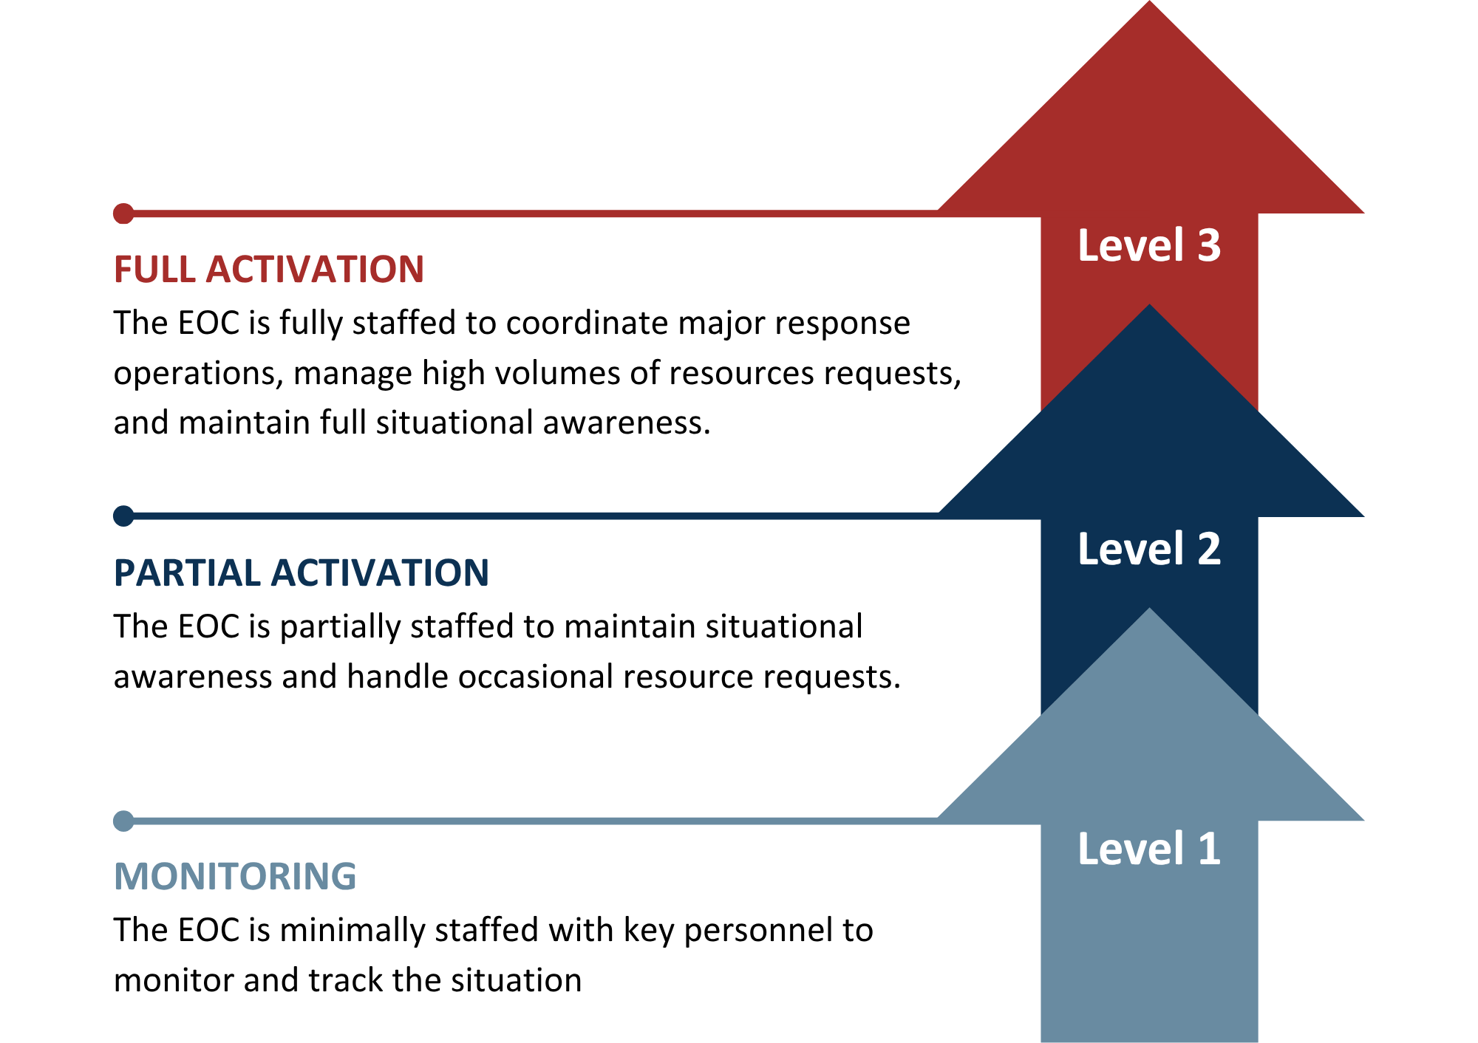
Public Health staff may be requested at any level to support coordination efforts. If Dover Board of Health activates a Public Health DOC, it will follow these same activation levels.

E. DOC ACTIVATION NOTIFICATIONS

When the DOC is activated, the [Agency position of authority] (or designee) will notify DOC personnel and stakeholders.
Notify DOC personnel
Send an alert that includes:
- Brief incident summary
- Assembly/briefing time and location (or virtual link)
- How to check in (e.g., roll call, sign-in)
- Special instructions (e.g., travel routes, safety instructions, required PPE/equipment)
Activated personnel report directly and promptly to the DOC (or virtual DOC), attend the initial briefing, and begin operations.
Notify partners and stakeholders
Issue a message announcing the DOC activation and how to communicate with the DOC (primary phone, email, radio channel, and situation report schedule).
Notify:
- Municipal leadership and department heads
- 911 Dispatch
- MRPC Duty Officer
- Neighboring communities (list)
- Hospitals and healthcare partners (list)
- Other critical infrastructure/partners (list)

Refer to Appendix B for Contact List.

F. INCIDENT COMMAND SYSTEM

The National Incident Management System (NIMS) is the national approach for how government, nongovernmental organizations, and the private sector work together to prevent, protect against, mitigate, respond to, and recover from incidents. A key component of NIMS is the Incident Command System (ICS), which provides a common structure that organizes personnel, facilities, equipment, procedures, and communications for effective and efficient incident management.

Public Health use of ICS
When Dover Board of Health is the lead for an incident:
- The [Agency position of authority] (or designee) assigns an Incident Commander (IC) to manage and direct the department’s response and recovery.
- The IC coordinates public health operations on behalf of the [Agency position of authority].
- The IC activates Command Staff and General Staff positions as needed.
- All DOC staffing and actions follow ICS and NIMS principles.

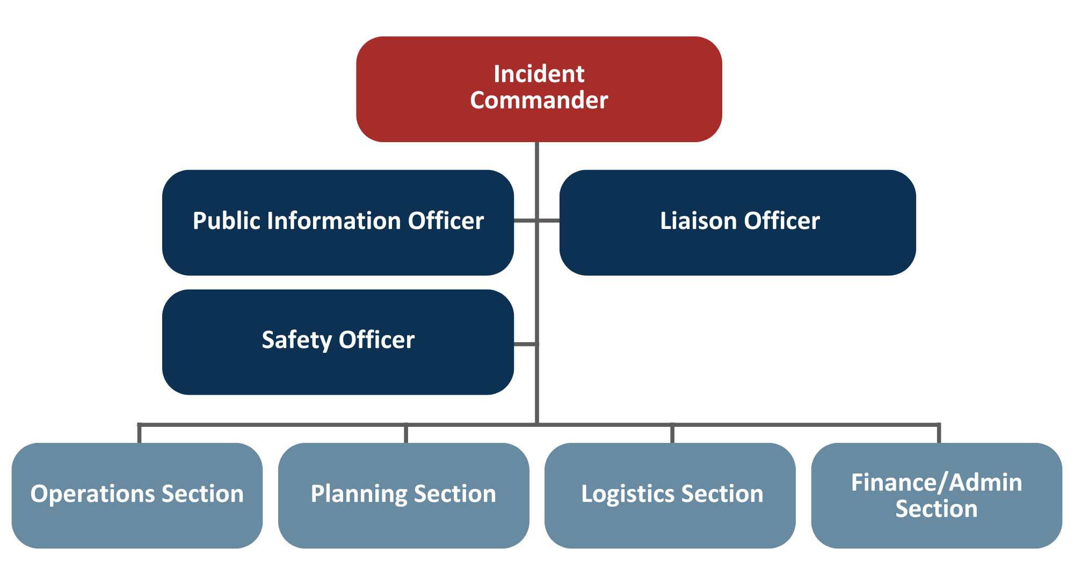
Section | Responsibilities
Command |  | Support the Incident Commander (IC) in directing, ordering, and controlling response personnel and resources. These positions often include the Public Information Officer, Safety Officer, Liaison Officer, and other positions as required.  - Public Information Officer (PIO): Leads public and media communications; develops and maintains communication plans, protocols, messages, and public health education materials.  - Safety Officer (SO): Protects health, mental health, and safety of DOC staff and field staff; identifies hazards and unsafe situations, develops corrective measures, implements safety actions, and stops unsafe practices immediately.  - Liaison Officer (LO): Coordinates with assisting agencies, organizations, and EOCs; maintains a common operating picture; processes information and resource requests.  Note: Additional command roles may be added as needed.
Planning |  | Collects, analyzes, documents, and shares incident information; develops the Incident Action Plan (IAP); provides situational awareness and status updates to Command, Operations, and Logistics.
Operations |  | Directs and coordinates response activities to meet incident objectives and carry out the IAP(s).
Logistics |  | Obtains and tracks facilities, services, personnel, equipment, and materials that support operations.
Finance and Administration |  | Manages costs, contracts, and documentation; supports reimbursement and MEMA cost-recovery claims and applications.
Policy Group |  | Provides executive guidance and strategic direction to the IC:  - Develops and implements response and recovery policies  - Weighs political, legal, and social implications of policy implementation.  - Reviews and evaluates public health response and recovery operations.

Note: When Dover Board of Health is a supporting agency, staff may fill comparable role(s) in the Dover EOC.

G. INITIAL RESPONSE

The initial response covers the first 24 hours after the DOC is activated. During the initial response, the Dover Board of Health will:
- Use the Incident Assessment Form (Appendix A) to identify public health impacts, population impacts, response needs, and any urgent actions.
- Set initial objectives, assign roles, and establish communication methods (phone, email, radio, situation reports).
- Begin documentation and keep a running log of key decisions.
If activated to support the Dover EOC, staff will complete required ICS forms and follow directions from the EOC Manager and/or Incident Commander.

H. SUSTAINED RESPONSE

Sustained operations begin after the first Incident Action Plan (IAP) is developed, approved, and briefed. They continue for as long as needed to support response and recovery. During this phase, Dover Board of Health will:
- Run 24-hour or multi-shift operations (if needed) with clear handoffs.
- Update the IAP each operational period and brief all staff.
- Maintain situational awareness, regular reports, and partner coordination.
- Track resources, costs, and staff time; request mutual aid as needed.
- Protect staff health and safety (rest, rotation, behavioral health).
- Plan and start demobilization while transitioning to recovery.
Sustained response ends when operational objectives are met, recovery operations take over, and the DOC Deactivation/Demobilization Plan is carried out.

I. ISSUANCE OF LOCAL PUBLIC HEALTH ORDER

Under Massachusetts General Laws Chapter 111, Section 31, local boards of health may issue reasonable regulations and orders to protect public health and safety. The orders can address sanitation, nuisances, disease control, and/or other mitigation measures during a health emergency. If needed, the Dover Board of Health should consult with Dover Counsel before issuing or enforcing a public health order.
Municipalities may also declare a local state of emergency when local resources are overwhelmed. Only the Chief Elected/Appointed Official may issue the declaration, which can authorize:
- Emergency spending or procurement
- Public safety orders such as evacuation, curfew, quarantine, or shelter in place directives
For more information, see the Dover CEMP.

J. FINANCE AND ADMINISTRATION

The Finance and Administrative Section supports DOC operations by tracking expenses, personnel time, and resources throughout response and recovery. All activities follow established financial and procurement procedures.
Financial Management
The Finance Section manages all financial transactions related to the response and recovery. This includes maintaining accurate records and supporting documentation for all expenditures. Eligible costs may be reimbursed by state or federal agencies, depending on the scope of the emergency and any declared disaster by the Governor of Massachusetts or the President of the United States.
- Emergency Purchasing
When a threat to public health, welfare, property, or safety exists, and normal procurement procedures are impractical, the Chief Procurement Officer may authorize emergency purchases. Such purchases should involve as much competition that is practicable under the circumstances. See [insert local procurement policy] for additional details.
- Nonexpendable Resources Accounting
Nonexpendable resources (e.g., capital asset items, equipment, vehicles, trailers, etc.) used during a response must be:
- Tracked and documented during the response,
- Restored to full working condition, and
- Returned to their original division, office, or program after use.

Items obtained through mutual aid must be returned to the providing organization as outlined in the agreement. Fixed facilities used in response must also be restored to their full functional capability.
- Expendable Resource Accounting
Expendable Resources (e.g., water, food, fuel, and other single-use supplies) must be fully documented and replenished by Dover Board of Health or as specified in funding agreements. Restocking occurs through the same source or vendor from which a resource was issued.
- Reimbursement
Reimbursement helps to recover funds spent on disaster response and recovery. When possible, use pre-established reimbursement agreements. Key activities include:
  - Collecting and verifying invoices and supporting documents
  - Tracking and reconciling all expenses
  - Validating costs against the scope of the work
  - Securing proper authorizations
  - Using correct forms, software, and reporting procedures

Administration
Effective response requires timely, accurate reporting and continuous recordkeeping. All records and reports must follow NIMS principles.
- Documentation
Create a complete, accurate record of response and recovery activities. This record supports decision-making, improves future plans, and enables cost recovery. Include (as applicable):
  - Situation reports, narratives, and operational logs
  - Damage assessments and maps
  - IAPs
  - Personnel time, resource use, and expense records
Send copies of all response and recovery documents to the DOC Planning Section for the official disaster record.
- Cost Recovery
Some response and recovery costs may be reimbursable if state and/or federal criteria are met.
  - Start cost tracking at the onset of the incident.
  - For each department or program, track its disaster-related expenses and report them to the DOC Finance Section.
  - Use approved forms, system, and procedures to ensure eligibility.

K. DEACTIVATION/DEMOBILIZATION

Deactivation of the DOC occurs as response and recovery activities wind down. The DOC IC recommends deactivation or a change in the activation level to the [Agency position of authority] who approves the decision.

Demobilization Process
- The DOC staff prepares a Demobilization Plan, which outlines how positions, activities, and responsibilities will be phased out or reassigned. The Demobilization Plan must be approved by the [Agency position of authority].
- Tasks may return to routine departments or programs once emergency operations end.
- Equipment and supplies must be returned, replenished, or restored to original supply and condition. All returned items should be inspected, cleaned, and inventoried.

Staff and Health Support
Following demobilization, hold post-incident debriefings for all staff. Provide information on available occupational and mental health services and, if needed, establish a program to monitor the short- and long-term health impacts on personnel.

Records and Close Out Activities
Collect and organize response information, resource data, and damage assessment information for the permanent record. Complete financial reconciliation, including resources used, equipment use, personnel time, and disaster-related expenses, to support potential state or federal reimbursement.

After-Action Review
Develop an After-Action Report (AAR) and Improvement Plan (IP) to document:

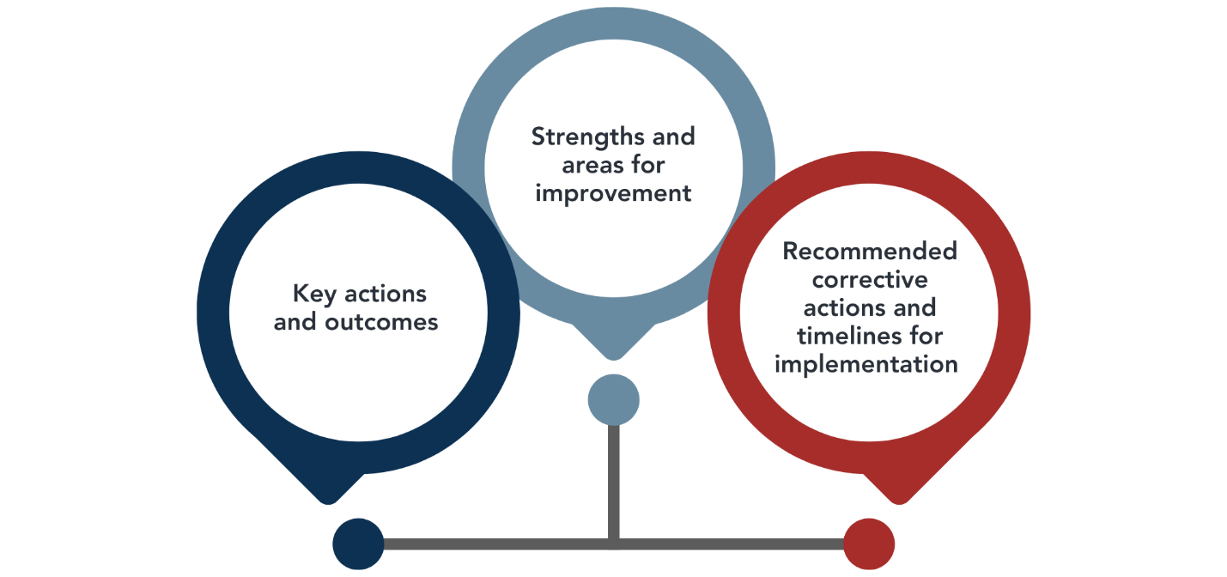

IV. Information Management

A. INFORMATION MANAGEMENT

Alert and Notification
Notify Dover Board of Health immediately when any of the following occur:
- Threats to public health or safety (e.g., outbreaks, contamination, mass exposure).
- Reportable diseases as required by Chapter 105, Code of Massachusetts Regulations (CMR), Section 300.000: Reportable Diseases, Surveillance, and Isolation & Quarantine Requirements.
How to report (24/7)

- Phone: [primary number] | After-hours: [on-call number]
- Email (non-urgent only): [address]
- State systems (if applicable): [e.g., MAVEN, WebEOC]
- Provide: who is reporting, what happened, when/where, people affected, immediate actions taken, and callback number.
- For life-threatening emergencies, call 911 first, then notify Dover Board of Health.

Operational Communications
Effective response depends on clear, reliable communication among staff, partners, vendors, and stakeholders.

Communication Methods
Dover Board of Health uses the following communication methods:
- Email distribution lists
- Calling lists (phone trees)
- Municipal Emergency Notification System
- Add others
During an activation, the Dover Board of Health will share updated contact information and designate primary and alternate points of contact.
The DoverEmergency Management Department manages public alert and warning systems. See the CEMP for details on system authority and use.
- Communication with Region 4AB HMCC
The MRPC provides 24/7/365 coverage through its Duty Officer to support regional coordination and information sharing. Notify the MRPC Duty Officer of any emergency or potential incident that could have regional impacts and/or exceed local response capacity. Examples include, but are not limited to:
  - Mass Casualty Incidents (MCIs)
  - Hazardous materials spills
  - Public Health emergencies
  - Major facility damage or service interruption requiring evacuation
For procedures, see the MRPC 24/7/365 Duty Officer Standard Operating Procedures.

24/7/365 MRPC Duty Officer: (857) 239-0662

- Communication with MDPH
The Massachusetts Department of Public Health (MDPH) Office of Preparedness and Emergency Management (OPEM) maintains a 24/7 Duty Officer to manage large-scale public health and healthcare emergencies.

Notify the MDPH OPEM Duty Officer prior to notifying the MRPC Duty Officer when any of the following occur:
  - A hospital declares Code Black
  - A MassMAP activation is requested
  - A CMED notification to OPEM (e.g., Mass Casualty Incident)
Otherwise, notify the MRPC Duty Officer first.
24/7/365 MDPH OPEM Duty Officer: (617) 339-8391

B. INFORMATION SHARING
Clear and timely information and situational awareness data ensures a common operating picture.
How Dover Board of Health manages information
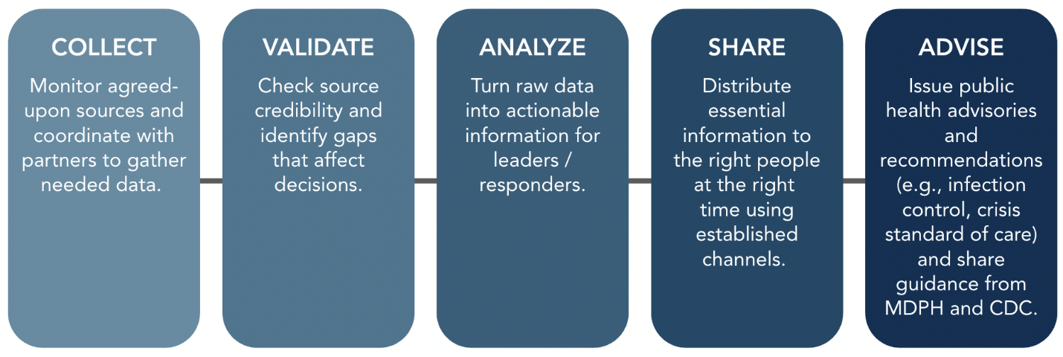
Common information sources
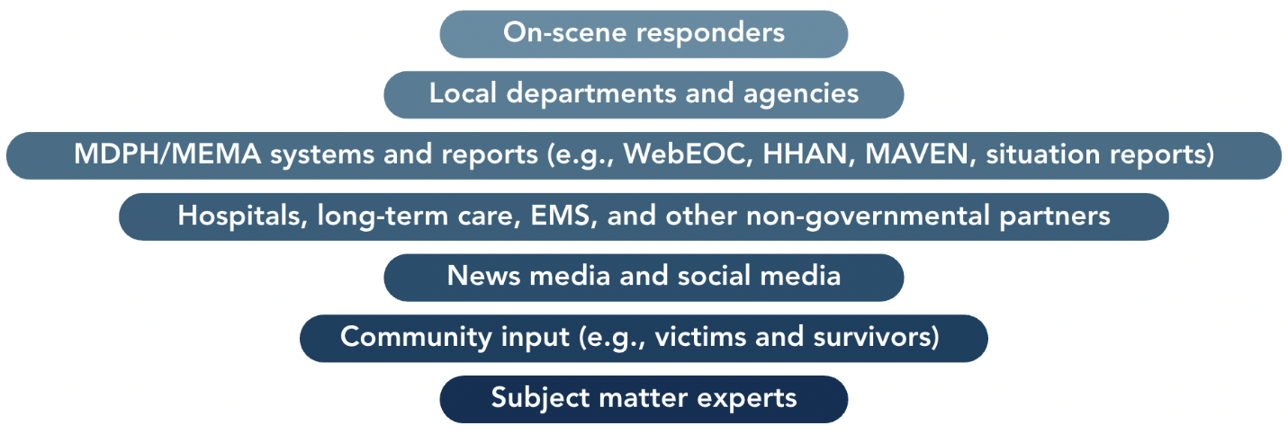
Sharing Tools

Additional jurisdiction-based tools
MDPH systems (WebEOC, HHAN, MAVEN)
Virtual meeting platforms
Dover Board of Health website, dashboards, and social media (if applicable)
Telephone and email
Information Systems and Their Use

Tool | What it’s for | Key Notes
Web Emergency Operations Center (WebEOC) | Health and medical incident management; maintaining situational awareness and a common operating picture. | MDPH and MEMA run separate WebEOC systems. MDPH WebEOC is not monitored 24/7. Local Boards of Health (LBOH) use it to share information with partners and document actions for accountability and potential reimbursement.
Health and Homeland Alert Network (HHAN) | Secure alerts and information sharing with public health and healthcare partners (e.g., disease updates, clinical guidance, standing orders). | Used by MDPH and all 351 municipalities. Designed for timely, targeted alerts and protected communications.
Massachusetts Virtual Epidemiologic Network (MAVEN) | Statewide disease surveillance and case management; captures lab, clinical, and public health data. | Supports electronic lab reporting (ELR) and sends automatic 24/7/365 notifications to state and local officials for events needing attention. By law, LBOH, providers, and labs must report notifiable diseases in MAVEN.

C. EMERGENCY PUBLIC INFORMATION AND WARNING
Dover Board of Health develops, coordinates, and disseminates information, alerts, warnings, and notifications during any incident with public health impacts.
What we communicate | Messages should:  - Use plain language (about a 6th-grade reading level).  - Be clear, concise, and actionable.  - Match the urgency of the situation.  - Align with state and federal guidance.  - Include supporting materials (FAQs, graphics, translations) as needed.
Who speaks | - The Public Information Officer (PIO) or designee is the only person authorized to speak to the media.  - The PIO coordinates message development with subject matter experts.
How we reach people | Choose the best channels for the audience and access needs:  - News releases and media briefings  - Website updates and dashboards  - Social media posts  - Public service announcements and paid ads  - Talking points for officials and call centers  - Multilingual and accessible formats (e.g., large print, ASL, captioning)
Reaching at-risk groups | Identify populations at greater risk and tailor messages and delivery methods (e.g., language access, trusted messengers, community partners).
Addressing misinformation | - Monitor media and social media for rumors and errors.  - Correct misinformation quickly - preferably before the next news cycle.  - Share consistent updates and point to official sources (MDPH, CDC).

Message Development, Approval, and Distribution
Public information staff use the steps below to create clear, accurate, and timely messages. See the Dover Board of Health Crisis and Emergency Risk Communication (CERC) Plan for detailed roles, templates, and workflows.
Develop the message | - Work with subject matter experts (SMEs) to draft plain language content with clear actions.  - Apply CERC principles (see Appendix C): be first, be right, be credible, express empathy, promote action, show respect.  - Consider:  - Who is speaking (spokesperson)  - How fast the message is needed (time pressure)  - Why you’re communicating (purpose and desired action)
Validate the information | - Confirm facts, numbers, sources, and dates with SMEs.  - Align with MDPH/CDC guidance and local policies.
Tailor for the audience | - Identify at-risk and vulnerable groups.  - Provide translation and accessible formats (e.g., large print, captions, plain language).  - Choose trusted messengers and partners to extend reach.
Approve and release | - PIO or designee drafts the content.  - SME(s) review for technical accuracy.  - EOC Manager or designated authority approves.  - PIO distributes through approved channels (website, social media, media release, alert system, call scripts).
Monitor and update | - Track public questions, uptake, and misinformation.  - Correct errors quickly and update messages as conditions change.

V. Biosurveillance

A. PUBLIC HEALTH LABORATORY TESTING

The Massachusetts State Public Health Laboratory provides laboratory services for diagnosis, surveillance, investigation, and prevention of public health threats. Guidance on specimen collection, packaging, transportation, and submission is available on their website and in current plans, policies, and procedures.
Dover Board of Health may use surge strategies during a public health emergency, such as:
- Utilizing Public Health Nurses to collect specimens.
- Partnering with local commercial laboratories for overflow testing.
[Add any agreements, partnerships, or other local plans related testing]

B. PUBLIC HEALTH SURVEILLANCE

Public health surveillance involves collecting, analyzing, and interpreting health data to monitor disease trends, identify outbreaks, and guide public health actions.
The Massachusetts Virtual Epidemiological Network (MAVEN) is a secure, web-based system used by the Massachusetts Department of Public Health Bureau of Infectious Disease and Laboratory Sciences (MDPH-BIDLS) and local boards of health to manage reportable disease data. MAVEN:
- Automates disease reporting from clinicians and laboratories.
- Integrates with the Health Information Exchange (HIE) for rapid electronic notifications.
- Supports case investigation, follow-up, and reporting.
When a reportable disease is diagnosed and/or confirmed, it is entered into MAVEN and routed to the local health department where the individual resides. Data are used to:
- Detect and control disease outbreaks.
- Ensure patients receive proper treatment.
- Provide testing and preventative care to exposed individuals.
MDPH also issues regular surveillance reports on arboviruses, foodborne illness, influenza activity, and other infectious diseases.
[Add other sources of public health data and surveillance; you may also choose to list the roles that have been trained/have access to MAVEN]

C. PUBLIC HEALTH EPIDEMIOLOGICAL INVESTIGATION

An epidemiological investigation identifies the cause of illness and guides control measures to prevent further spread.
[Name of Agency/Role] will follow established procedures, for case investigation including:
- Developing a case definition to consistently classify cases.
- Developing a questionnaire to collect demographic, clinical, and exposure information.
- Interviewing cases in person, by phone, or through a secure self-reporting tool.
If applicable, MDPH may provide standardized tools or questionnaires. Once data are analyzed, findings will be used to determine the source of infection and to implement control measures.

D. CONTACT TRACING

During an epidemiological investigation, Dover Board of Health may conduct contact tracing, identify and notify people who were recently exposed to an infected individual.

Contact tracers will:
- Reach out to exposed individuals to provide guidance on testing, isolation, or other precautions.
- Follow up during the incubation period to monitor for symptoms or positive results.
- Use standardized scripts, data collection forms, and guidance materials developed and approved by MDPH/CDC.
- Provide contacts with instructions on what to do if they develop symptoms and who to notify if they become symptomatic.

V. Countermeasures and Mitigation

A. MEDICAL COUNTERMEASURE DISPENSING AND ADMINISTRATION

Dover Board of Health is responsible for dispensing and administering medical countermeasures (MCMs), such as vaccines, antiviral drugs, antibiotics, and antitoxins, to protect affected populations during a public health emergency in accordance with state and federal guidelines.
When needed, Dover Board of Health will activate and operate Emergency Dispensing Sites (EDSs) to dispense or administer MCMs. Key responsibilities include:
- Site identification and setup: Select accessible, high-capacity locations for EDS operations.
- Infrastructure readiness: Ensure medical supplies, equipment, staffing, and communication systems are in place.
- Staffing and training: Recruit, train, and deploy healthcare workers, public health nurses, and support staff.
- Supply and logistics: Coordinate the receipt, storage, and delivery of medical countermeasures.
- Data tracking: Record doses dispensed, individuals served, and any adverse reactions.
- Safety and security: Coordinate with law enforcement to protect staff, clients, and assets.
- Infection control: Follow PPE, sanitation, and distancing protocols to prevent disease spread.
- Privacy compliance: Handle all medical data in accordance with HIPAA and other privacy laws.
- Reporting: Maintain accurate records of EDS activities and share data with MDPH as required.
[Reference your agency’s Emergency Dispensing Plan, mass vaccination plan, and any other applicable guidance or roles]
[Outline any staffed Public Health Nurse positions, authorized to administer vaccines]

B. MEDICAL MATERIEL MANAGEMENT AND DISTRIBUTION

Dover Board of Health will acquire, manage, transport, track, and recover medical materiel during a public health emergency. This includes items such as pharmaceuticals, vaccines, gloves, masks, ventilators, and other medical equipment.

When activated, the DOC coordinates all resources assigned to public health operations - whether requested from the field, directed through DOC mission tasking (e.g., EDS), or supporting other response or recovery activities.

Dover Board of Health maintains a limited supply of equipment and materials used for day-to-day operations. Additional supplies, personnel, and funding may be obtained through:
- Local or regional caches (e.g., MRPC)
- Mutual aid agreements
- Vendor contracts
- Other government agencies or jurisdictions
- Nonprofits, NGOs, or private-sector partners
- Donations or volunteers
Resource Requests
If existing inventory cannot meet operational needs, Dover Board of Health will use vendor agreements, mutual aid, or regional coordination through the MRPC.
- Resource Request to Dover EOC
When the EOC is activated, resource requests are coordinated through the Logistics Section. The EOC may:
  - Fulfill requests locally, or
  - Submit requests to MEMA by phone, radio (to the Regional Office or HQ), or through the MEMA WebEOC.
See the Dover CEMP for full procedures.
- Resource Request to MRPC
The MRPC manages regional caches of PHEP, MRC, and HPP supplies stored in Waltham, MA. The MRPC can also coordinate resource sharing among regional partners or with the state.T AND DISTRIBUTION, continued

Submit requests to the MRPC Duty Officer per the MRPC Response Plan:
  - mrpcdutyofficer@challiance.org | (857) 239-0662

Resource Accountability
The requesting agency will manage and document all received resources.
- Inspect and inventory all items upon receipt.
- Keep bills of lading or shipping documents and track where items are deployed.
- Return demobilized resources to their original facility after inspection for damage, cleanliness, and serviceability.
- Replace any items that cannot be returned with those of equal quality and quantity.
- If eligible, coordinate with the Dover Emergency Management Department and MEMA for cost recovery or reimbursement of emergency-related expenses.
- Maintain all records and documentation for potential state or federal reimbursement audits.

C. NONPHARMACEUTICAL INTERVENTIONS

Nonpharmaceutical interventions (NPIs) are actions - other than medical treatments like vaccines or medications - that people and communities can take to help prevent or slow the spread of illness. NPIs can target individuals, groups, or environments and are often the first line of defense when vaccines or medicines are not available.

Types of NPIs
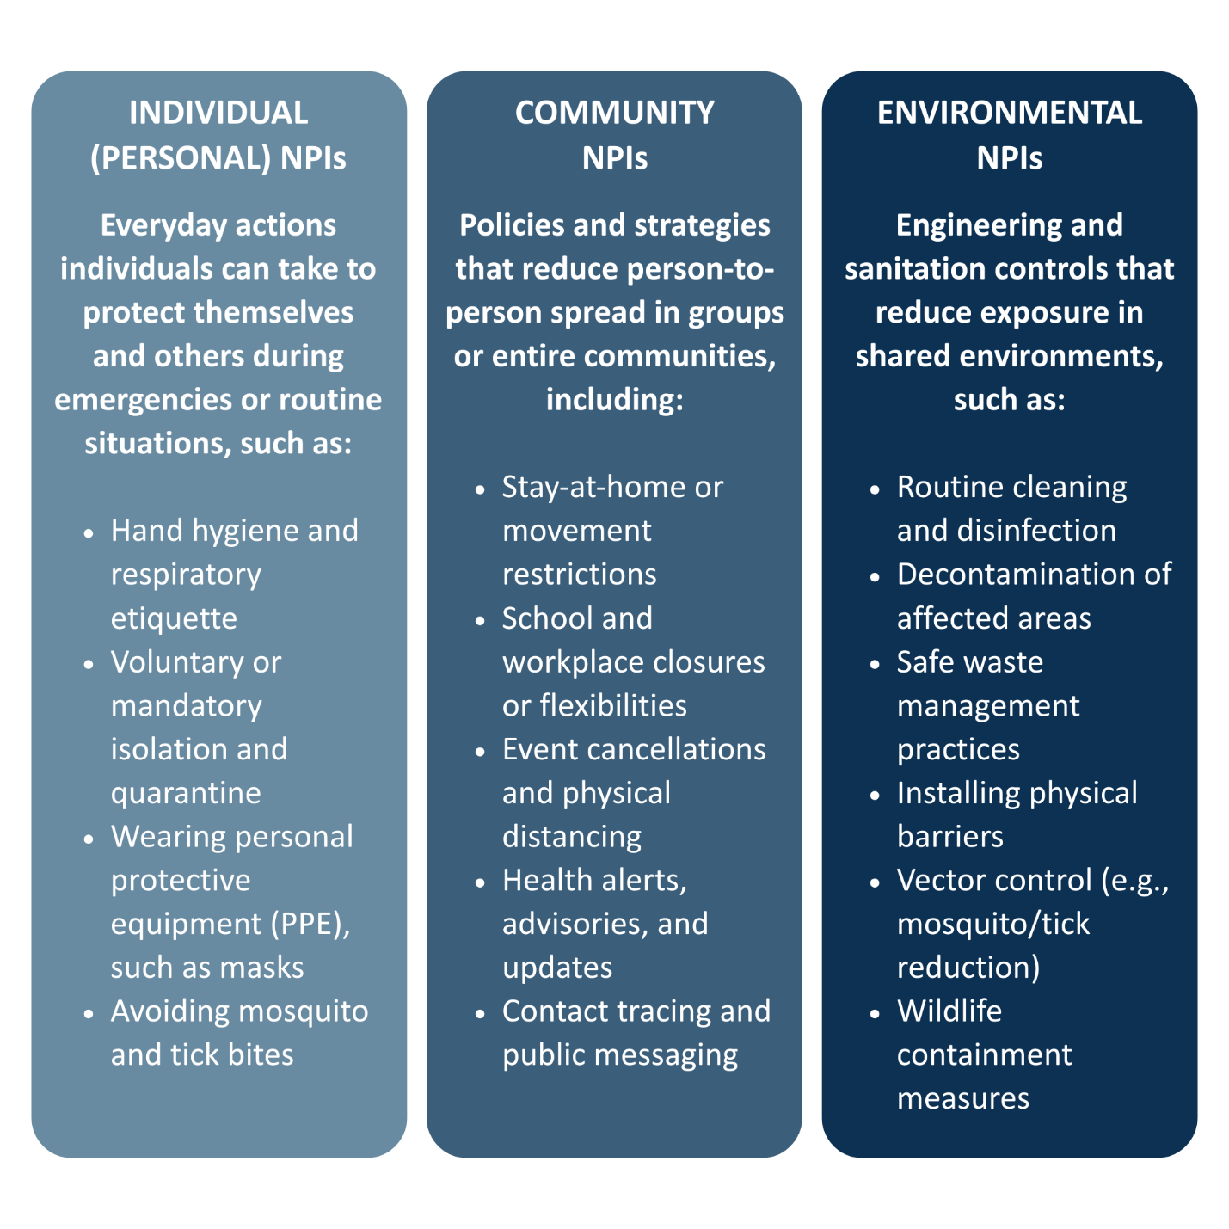
Key Definitions
- Isolation: Separating people who are ill with a contagious disease to prevent transmission.
- Quarantine: Separating people who are not sick but may have been exposed until it is clear they are not contagious (typically one incubation period).
- Physical distancing: Increasing space between individuals in settings where close contact occurs.

Implementation Notes
- Individual and environmental NPIs are the most practical and commonly used.
- Community-wide NPIs may be necessary during severe outbreaks or widespread hazards to protect public health.
- All NPIs should be based on public health guidance and tailored to the type, scale, and severity of the incident.

Interventions that may be considered for biological or infectious disease outbreaks include, but are not limited to, the following:

Individual/ Personal NPIs | Community NPIs | Environmental NPIs
- Voluntary Self-Isolation  - Mandatory Isolation  - Voluntary Self-Quarantine Mandatory Quarantine  - Cough Etiquette  - Hand Hygiene  - Personal Protective Equipment (PPE): Respiratory Protection (Masking)  - Mosquito and Tick Bite Prevention | - Patient and/or Staff Cohorting  - Stay-At-Home Order  - Restrictions on Movement and Travel  - Workplace and/or School Flexibilities  - Travel Advisories & Warnings  - Health Alerts, Advisories, & Updates  - Evacuation/Relocation  - Facility Closures  - Mass Gathering Cancellations or Postponement  - Physical Distancing  - Public Health Surveillance  - Contact Tracing  - Public Health Messaging & Education | - Routine Surface/Object Cleaning  - Decontamination  - Waste Management  - Creation of Physical Barriers  - Mosquito & Tick Control (Source Reduction)  - Environmental and Wildlife Containment

D. RESPONDER SAFETY AND HEALTH

Dover Board of Health will support protecting the physical and mental health of responders and volunteers before, during, and after a public health emergency.
Key Responsibilities
- Identify hazards and risks: Determine potential dangers responders may face and who is most at risk.
- Mitigate risks: Develop and implement health and safety measures (e.g., PPE, safe work practices).
- Monitor evolving needs: Adjust safety measures as conditions change.
- Conduct safety briefings: Provide ongoing safety updates and reminders for deployed staff.
- Document incidents: Record and address any injuries, exposures, or adverse events.
- Follow up after demobilization: Monitor responders for any short- or long-term health or behavioral effects.
Risk Awareness
All responders must understand that no level of risk is acceptable unless the potential benefit outweighs the danger. Risk is part of disaster response, but it can be reduced through awareness, preparation, and mitigation.

Common Safety and Health Hazards
- Safety hazards: Uneven or wet surfaces, low lighting, damaged structures, debris, live electrical wires, traffic, or severe weather.
- Health hazards: Poor air quality, exposure to hazardous materials, repetitive motion injuries, heat or cold stress, or infectious disease exposure.
- Behavioral health hazards: Fatigue, burnout, stress, anxiety, and reduced morale during or after deployment.

Post-Deployment Support
After an activation, Dover Board of Health will assess whether responders experienced adverse physical or mental effects and identify trends that could signal broader risks. The agency will provide or coordinate:
- Medical and behavioral health support for affected staff.
- Referrals through [Human Resources/Risk Management] for post-exposure care or counseling.
- Access to the Employee Assistance Program (EAP) and other available wellness resources.

A culture of safety and self-care is essential—responders should be encouraged to seek help early and report safety or health concerns immediately.

VII. Surge Management

A. FATALITY MANAGEMENT

The Massachusetts Office of the Chief Medical Examiner (OCME) has legal authority over deaths that are violent, suspicious, or unexplained. Deaths in healthcare facilities follow normal reporting and are usually handled through funeral homes.
A mass fatality incident refers to when more dead bodies or body parts can be located, identified, and processed for final disposition by available response resources.
Public health is not the lead agency but plays key supporting roles, including:
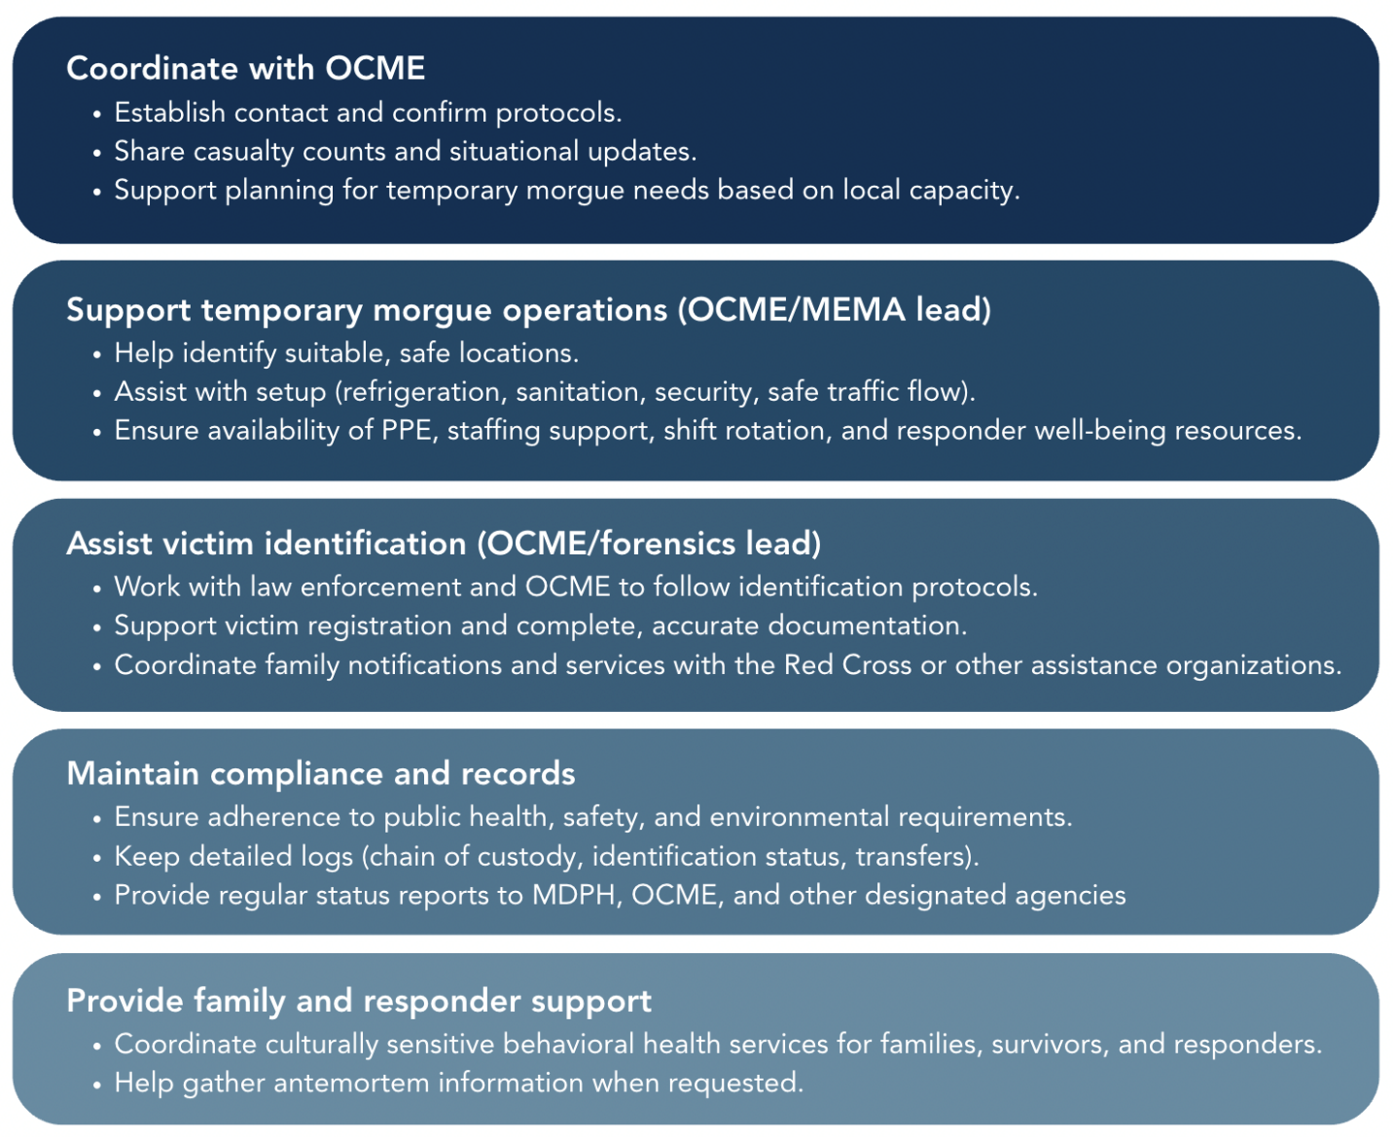

B. MASS CARE

Mass care involves coordinating with partner agencies to meet the public health, healthcare, behavioral health, and human services needs of people in congregate settings (not including shelter-in-place locations).
Public health is not the lead agency but plays key supporting roles, including:
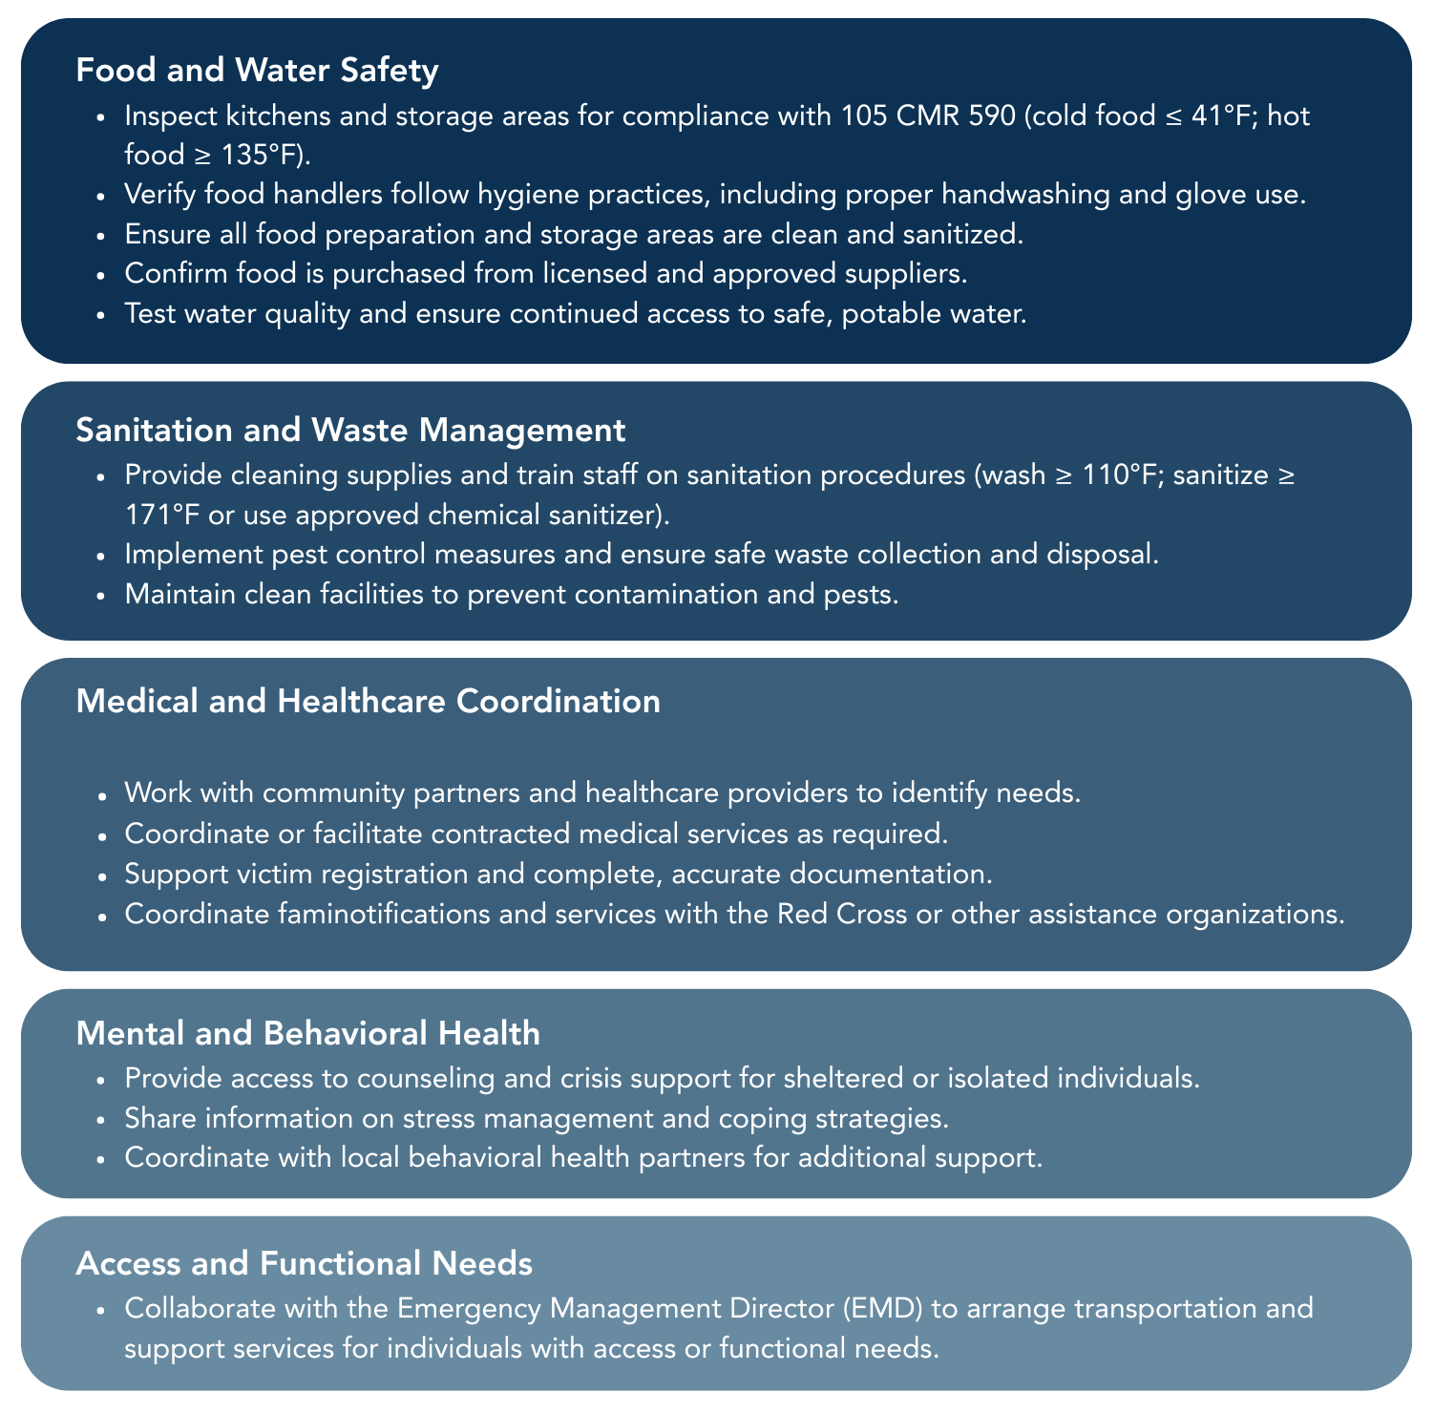
Dover Board of Health does not provide direct medical care in shelters but will:

C. MEDICAL SURGE

Medical surge is the ability of the healthcare system to provide adequate evaluation and care when demand exceeds normal capacity. It includes staying operational during a hazard and restoring services quickly after disruptions.
Healthcare facilities manage their own surge plans. Dover Board of Health supports them by sharing information, coordinating resources (including medical countermeasures), and conducting surveillance and investigations.
Event Recognition
Dover Board of Health may identify a surge through indicators such as:
- A confirmed case of a rare or highly infectious disease
- Unusual clusters of illness
- A mass-casualty incident
- A prolonged or severe infectious disease season
Hospitals or 911/EMS may also report surge conditions directly.
Preparedness
Dover Board of Health works with the Region 4AB HMCC, MDPH, and local health partners to plan for surge.
- Participate in Region 4AB HMCC meetings and activities.
- Coordinate with local planning groups (e.g., LEPC) and healthcare partners.
- Maintain a current list of facilities in Dover:
  - [Hospitals / urgent care / long-term care / dialysis / behavioral health, with type/level of care and contact info.]
Response Actions
During a surge, Dover Board of Health may:
- Support triage and patient tracking; monitor bed status and facility impacts.
- Serve as a liaison between healthcare providers and local/regional/state partners.
- Assist with patient evacuation and repatriation, including transfers to definitive care.
- Help implement family reunification processes for transferred patients.
- Coordinate logistics for medical countermeasures and provide technical guidance.
- Medical surge is the ability of the healthcare system to provide adequate evaluation and care.
- Organize or connect facilities to support services (e.g., casualty management, behavioral health).
- Identify needs for emergency resources and equipment and assist with requests.
- Identify at-risk or disproportionately impacted populations and share protective actions (e.g., evacuation routes, shelter-in-place, decontamination).

D. VOLUNTEER MANAGEMENT

Dover Board of Health works with emergency management and partner organizations to identify, recruit, register, train, and deploy volunteers to support public health preparedness, response, and recovery activities. Common volunteer resources include the Medical Reserve Corps (MRC) and other community-based groups.
Dover is a part of the Middlefolk MRC, which includes the following communities:

- Ashland
- Dover
- Framingham
- Holliston
- Hopkinton
- Medfield
- Millis
- Norfolk
- Sherborn
- Wrentham
Activation and Coordination
When additional personnel are needed, the Volunteer Coordinator (or designee) will:
- Notify and mobilize volunteers.
- Verify credentials, training, and background checks (e.g., CORI/SORI).
- Assign roles and responsibilities.
- Coordinate deployment logistics, including site access and reporting.
Volunteer Management Tasks
When utilizing volunteers, Dover Board of Health should consider the following tasks:
- Establish and staff a check-in/check-out process.
- Prepare required forms and maintain documentation.
- Set up and mark staging or intake areas.
- Verify photo IDs and professional licenses/certifications.
- Assign duties based on skills and qualifications.
- Provide role-specific identification and communication tools (e.g., radios).
- Track attendance and report “no-shows” to plan for coverage.

Partnerships and Additional Resources
The Region 4AB MRC Coordinator can provide support in coordinating volunteer requests. See Appendix G for the MRC Region 4AB Request for Assistance form.
Additional volunteer resources may also be available through the American Red Cross, Voluntary Organizations Active in Disasters (VOAD), and other community-based organizations.

[Reference additional plans/protocols such as Volunteer Management Plan, job aids, and/or other local or regional volunteer documents or resources].

EQUITY IN PUBLIC HEALTH RESPONSE
About [X] people ([x]% of residents) in Dover have access or functional needs that can affect their ability to get medical care or emergency services.
Dover Board of Health is committed to equitable preparedness, response, and recovery. This includes actions to:
- Create policies and procedures that reflect our community’s diversity and unique needs.
- Engage a wide range of community partners and trusted messengers.
- Provide culturally and linguistically appropriate information and services.
KEY TERMS
Access and Functional Needs (AFN)
Access needs: People need resources—such as information, social services, or transportation—in accessible formats and venues.
Functional needs: People may have limitations that require assistance before, during, or after an emergency to maintain health, safety, or independence.

At-Risk Populations
Under federal law (PAHPAIA), “at-risk” includes people with temporary or permanent AFN that may limit access to care. Examples include:
- Children; pregnant people; older adults
- People with disabilities or chronic conditions; those dependent on medications
- People with limited English proficiency or from diverse cultures
- People with limited transportation; those living in poverty or unhoused
- LGBTQ+ individuals and other groups who may face barriers to care
The largest at-risk population groups within Dover are:
- Group 1
- Group 2
- Group 3
*Add additional as desired/applicable

Using the CMIST Framework
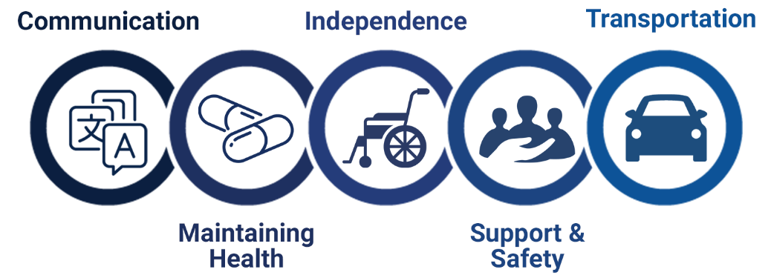
At-risk individuals may have a number of additional needs that must be considered in planning for, responding to, and recovering from a disaster or public health emergency. The CMIST Framework is a recommended approach for integrating the AFN of these individuals. CMIST is an acronym for the following five categories: Communication, Maintaining Health, Independence, Support and Safety, and Transportation.

Practical Strategies for Equity
- Identify and map needs: Use current census, social services, and local data tools.
- Tailor communications: Provide plain language, translations, accessible formats, and use trusted messengers.
- Coordinate services: Work with emergency support partners and community-based organizations to ensure accessible resources.
- Target outreach: Reach people who may not use traditional systems (e.g., homebound, unhoused).
- Train responders: Provide training on cultural competence, disability awareness, and trauma-informed care.
- Engage the community: Hold forums, surveys, and feedback sessions to find gaps and improve services.
- Build resilience: Offer preparedness education and resources before, during, and after incidents.
Disproportionately Impacted Populations
Groups that face greater harm from social, health, or environmental factors (e.g., low-income communities, racial/ethnic minorities, older adults, LGBTQ+ people, people with chronic illness, or communities with low trust in government, including some Indigenous communities). Planning should address both at-risk and disproportionately impacted groups.

Hazard | Anticipated Disproportionately Impacted Populations
Extreme Temperatures | [Reference your jurisdiction’s extreme temperature data profile and include here]  https://region4ab.org/phep/extremetemps/
Hurricane | [Reference your jurisdiction’s hurricane data profile and include here]  https://region4ab.org/phep/hurricane/
Add additional hazard from your jurisdiction’s Hazard Mitigation Plan and/or the region’s HVA or JRA | [Develop based on the related hazard]
Add additional hazard from your jurisdiction’s Hazard Mitigation Plan and/or the region’s HVA or JRA | [Develop based on the related hazard]

Public Health Resources for Equity Planning
The table below includes a list of MDPH resources that may also be used to build a representative situation overview summary in preparation for future public health emergency response efforts.

Table 4: Public Health Planning Tools
Resource Name | Definition | Link
CMIST Framework | The CMIST Framework provides a flexible, crosscutting approach for planning to address a broad set of common A&FN without having to define a specific diagnosis, status, or label. CMIST consists of five categories (communication, maintaining health, independence, support and safety, and transportation) | Supporting At-Risk Individuals with Access & Functional Needs in Emergencies
MDPH Public Health Planning Toolkit for At-Risk Individuals with A&FN | The MDPH Public Health Planning Toolkit for At-Risk Individuals with A&FN provides a list of tools and resources to assist LBOH in supporting at-risk individuals and those who have A&FN before, during, and after a public health disaster | MDPH Public Health Planning Toolkit for At Risk Individuals with A&FN
MDPH Population Health Information Tool | The Population Health Information Tool (PHIT) provides up-to-date, easy-to-understand public health and racial equity data for each community in Massachusetts | Population Health Information Tool | Mass.gov

Appendix A

LOCAL PUBLIC HEALTH DECISION MATRIX

Incident date: 1/1/2026
Incident type: [Insert Response]
Incident description: [Insert Response]
Reported by: [Insert Name]
Lead agency: [Agency Name]
Decision to Activate:
No Activation Necessary
Level 1 – Monitoring
Level 2 - Partial Activation
Level 3 - Full Activation
What are the public health impacts? [Insert Response]
Which populations are impacted? [Insert Response]
Highest risk? [Insert Response]
Disproportionately impacted? [Insert Response]
What public health actions are needed? [Insert Response]
What health and medical resources are needed? [Insert Response]
What public information is needed? [Insert Response]

Appendix B

CONTACT LIST

Agency Name/Role | Point of Contact | Phone | Email

Appendix C

MEMORANDUM OF AGREEMENT/UNDERSTANDING

Placeholder – Community to add list here, or alternatively communities can reference where to find them/who owns (e.g. Finance)

Appendix D

RELEVANT LAWS AND REGULATIONS

Federal Government
Table 1: Federal Laws and Regulations
Law/Regulation | Contents
Interstate Quarantine  Title 42, Code of Federal Regulations Part 70 | Authorizes the detention, isolation, quarantine, or conditional release of individuals for the purpose of preventing the introduction, transmission, and spread of the communicable disease listed in an Executive Order
Foreign Quarantine  Title 42, Code of Federal Regulations Part 71 | Authorizes the Director of the Centers for Disease Control and Prevention (U.S. CDC) to order the isolation, quarantine, or placement of a person under surveillance and may order other actions as considered necessary to prevent the introduction, transmission, or spread of the listed communicable diseases
Public Readiness and Emergency Preparedness Act (PREP Act)  As Amended - Public Law 109-148 | Authorizes the Secretary of the Department of Health and Human Services (HHS) to issue a declaration that provides immunity from liability (except for willful misconduct) for claims of loss caused, arising out of, related to, or resulting from the administration or use of countermeasures to diseases, threats, and conditions determined to constitute a present or creditable risk of a future public health emergency
Regulations to Control Communicable Diseases  Title 42, Code of Federal Regulations Part 264 | Authorizes the U.S. Surgeon General to make and enforce regulations to prevent the introduction, transmission, or spread of communicable diseases from foreign countries into the United States, or from one state to another
Suspension of Entries and Imports from Designated Places to Prevent Spread of Communicable Disease  Title 42, Code of Federal Regulations Part 265 | Whenever it is determined that there is serious danger of the introduction of a disease into the U.S., and that this danger is increased by the introduction of persons or property from the country of origin and that a suspension of the right to introduce such persons and property is required in the interest of the public health, the U.S. Surgeon General, in accordance with regulations approved by the President, shall have the power to prohibit the introduction of persons and property from such countries or places to avert danger - for any period of time the U.S. Surgeon General deems necessary
Pandemic and All-Hazards Preparedness Act (PAHPA)  Pub. Law No. 109–417 | Establishes the Assistant Secretary for Preparedness and Response (ASPR) with authority over the advanced development and acquisition of medical countermeasures. Also establishes the National Health Security Strategy (NHSS) to coordinate preparedness activities across agencies and organizations to reduce the social and economic cost of public health incidents
Public Health Service Act  Section 319, Public Health Emergencies | Authorizes the Secretary of HHS to determine whether a Public Health Emergency exists. If the Secretary determines that a disease or disorder exists as a public health emergency, they are authorized to take appropriate actions consistent with other authorities to respond to the emergency, temporarily suspend or modify certain legal requirements, and expand available funds in the Public Health Emergency Fund for the response
Robert T. Stafford Disaster Relief and Emergency Assistance Act (Stafford Act)  As Amended - Pub. Law 93-288 | Provides authority for response and recovery assistance under the Federal Response Plan, which empowers the President to direct any federal agency to utilize its authorities and resources in support of state and local disaster assistance efforts

State Government

Massachusetts Civil Defense Act
Table 2: State Laws and Regulations
Law/Regulation | Contents
Massachusetts Civil Defense Act | Requires every Massachusetts city and town to establish a local Emergency Management Agency (EMA) and appoint an official to oversee the program (Emergency Management Director, or EMD). The EMD, with assistance from other local officials (e.g., the Health Officer/Agent), is often responsible for directing evacuations, opening shelters, coordinating the actions of local departments and agencies, mobilizing resources, activating mutual aid agreements, requesting state assistance, and other actions, in accordance with local emergency plans and procedures

Local Government
Over the years, the Massachusetts Legislature has enacted numerous statutes that authorize LBOH to address a broad range of health, sanitation, and environmental issues at the community level. The following is a general, non-exhaustive list of those statutes.
Table 3: Local Laws and Regulations
Law/Regulation Type | Contents
General Health Protection and Regulation | - Adopt and enforce any reasonable health regulations - M.G.L. c.111, s.31  - Issue an order reciting the existence of an emergency and requiring that such action be taken as the board deems necessary to meet the emergency - State Sanitary Code, Chapter 1, 105 CMR 400.200(B), pursuant to M.G.L. c.111, s.127A; and State Environmental Code, Title I, 310 CMR 11.05(1)
Health Care and Disease Control | - Direct the operation of and adopt rules for city and town medical dental and health clinics - M.G.L. c.111, s.50 and hospitals, M.G.L. c.111, s.92  - Require vaccination of inhabitants of the city or town - M.G.L. c.111, s.181  - In cities, and in towns with a population greater than ten thousand, establish public sanitary stations - M.G.L. c.111, s.33  - Direct the isolation and quarantine of individuals and property relative to communicable disease - Chapter 111 sections 92-121A
Food Safety | - Inspect and condemn all unfit meat, fish vegetables, produce, fruit or provisions of any kind - M.G.L.. c.94, s.146; 105 CMR 590.059  - Adopt and enforce regulations related to the keeping and exposure of food for sale - M.G.L. c.94, 2.146  - Upon determination that drinking water in a dwelling or food service establishment is unsafe, order discontinuance of use or order provisions of a new source - M.G.L. c.111, s.122A
Miscellaneous | Adopt and enforce regulations to control air pollution - M.G.L. c.111, s.31C

Appendix E

CDC PUBLIC HEALTH EMERGENCY PREPAREDNESS AND RESPONSE CAPABILITIES

The CDC Public Health Emergency Preparedness and Response Capabilities: National Standards for State, Local, Tribal, and Territorial Public Health describe the components necessary to advance jurisdictional public health preparedness and response capacity.
Domain | Capability
Community Resilience | Community Preparedness
Community Resilience | Community Recovery
Incident Management | Emergency Operations Coordination
Information Management | Emergency Public Information and Warning
Information Management | Information Sharing
Countermeasures and Mitigation | Medical Countermeasure Dispensing and Administration
Countermeasures and Mitigation | Medical Materiel Management and Distribution
Countermeasures and Mitigation | Nonpharmaceutical Interventions
Countermeasures and Mitigation | Responder Safety and Health
Surge Management | Fatality Management
Surge Management | Mass Care
Surge Management | Medical Surge
Surge Management | Volunteer Management
Biosurveillance | Public Health Laboratory Testing
Biosurveillance | Public Health Surveillance and Epidemiological Investigation

Capability 1: Community Preparedness
Community preparedness is the ability of communities to prepare for, withstand, and recover from public health incidents in both the short and long term. Through engagement and coordination with a cross-section of state, local, tribal, and territorial partners and stakeholders, the public health role in community preparedness is to:
- Support the development of public health, health care, human services, mental/behavioral health, and environmental health systems that support community preparedness
- Participate in awareness training on how to prevent, respond to, and recover from incidents that adversely affect public health
- Identify at-risk individuals with access and functional needs that may be disproportionately impacted by an incident or event
- Promote awareness of and access to public health, health care, human services, mental/behavioral health, and environmental health resources that help protect the community’s health and address the access and functional needs of at-risk individuals
- Engage in preparedness activities that address the access and functional needs of the whole community as well as cultural, socioeconomic, and demographic factors
- Convene or participate with community partners to identify and implement additional ways to strengthen community resilience
- Plan to address the health needs of populations that have been displaced because of incidents that have occurred in their own or distant communities, such as after a radiological or nuclear incident or natural disaster
Functions: This capability consists of the ability to perform the functions listed below.
- Function 1: Determine risks to the health of the jurisdiction
- Function 2: Strengthen community partnerships to support public health preparedness
- Function 3: Coordinate with partners and share information through community social networks
- Function 4: Coordinate training and provide guidance to support community involvement with preparedness efforts
Capability 2: Community Recovery
Community recovery is the ability of communities to identify critical assets, facilities, and other services within public health, emergency management, health care, human services, mental/behavioral health, and environmental health sectors that can guide and prioritize recovery operations. Communities should consider collaborating with jurisdictional partners and stakeholders to plan, advocate, facilitate, monitor, and implement the restoration of public health, health care, human services, mental/behavioral health, and environmental health sectors to at least a day-to-day level of functioning comparable to pre-incident levels and to improved levels, where possible.
- Function 1: Identify and monitor community recovery needs
- Function 2: Support recovery operations for public health and related systems for the community
- Function 3: Implement corrective actions to mitigate damage from future incidents

Capability 3: Emergency Operations Coordination
Emergency operations coordination is the ability to coordinate with emergency management and to direct and support an incident or event with public health or health care implications by establishing a standardized, scalable system of oversight, organization, and supervision that is consistent with jurisdictional standards and practices and the National Incident Management System (NIMS).
- Function 1: Conduct preliminary assessment to determine the need for activation of public health emergency operations
- Function 2: Activate public health emergency operations
- Function 3: Develop and maintain an incident response strategy
- Function 4: Manage and sustain the public health response
- Function 5: Demobilize and evaluate public health emergency operations

Capability 4: Emergency Public Information and Warning
Emergency public information and warning is the ability to develop, coordinate, and disseminate information, alerts, warnings, and notifications to the public and incident management personnel.
- Function 1: Activate the emergency public information system
- Function 2: Determine the need for a Joint Information System
- Function 3: Establish and participate in information system operations
- Function 4: Establish avenues for public interaction and information exchange
- Function 5: Issue public information, alerts, warnings, and notifications

Capability 5: Fatality Management
Fatality management is the ability to coordinate with organizations and agencies to provide fatality management services. The public health agency role in fatality management activities may include supporting:
- Recovery and preservation of remains
- Identification of the deceased
- Determination of cause and manner of death
- Release of remains to an authorized individual
- Provision of mental/behavioral health assistance for the grieving
The role may also include supporting activities for the identification, collection, documentation, retrieval, and transportation of human remains, personal effects, and evidence to the examination location or incident morgue.
Functions: This capability consists of the ability to perform the functions listed below.
- Function 1: Determine the public health agency role in fatality management
- Function 2: Identify and facilitate access to public health resources to support fatality management operations
- Function 3: Assist in the collection and dissemination of antemortem data
- Function 4: Support the provision of survivor mental/behavioral health services
- Function 5: Support fatality processing and storage operations

Capability 6: Information Sharing
Information sharing is the ability to conduct multijurisdictional and multidisciplinary exchange of health-related information and situational awareness data among federal, state, local, tribal, and territorial levels of government and the private sector. This capability includes the routine sharing of information as well as issuing of public health alerts to all levels of government and the private sector in preparation for and in response to events or incidents of public health significance.
- Function 1: Identify stakeholders that should be incorporated into information flow and define information sharing needs
- Function 2: Identify and develop guidance, standards, and systems for information exchange
- Function 3: Exchange information to determine a common operating picture
Capability 7: Mass Care
Mass care is the ability of public health agencies to coordinate with and support partner agencies to address within a congregate location (excluding shelter-in-place locations) the public health, health care, mental/behavioral health, and human services needs of those impacted by an incident. This capability includes coordinating ongoing surveillance and assessments to ensure that health needs continue to be met as the incident evolves.
- Function 1: Determine public health role in mass care operations
- Function 2: Determine mass care health needs of the impacted population
- Function 3: Coordinate public health, health care, and mental/behavioral health services
- Function 4: Monitor mass care population health
Capability 8: Medical Countermeasure Dispensing and Administration
Medical countermeasure dispensing and administration is the ability to provide medical countermeasures to targeted population(s) to prevent, mitigate, or treat the adverse health effects of a public health incident. This capability focuses on dispensing and administering medical countermeasures, such as vaccines, antiviral drugs, antibiotics, and antitoxins.
- Function 1: Determine medical countermeasure dispensing/administration strategies
- Function 2: Receive medical countermeasures to be dispensed/administered
- Function 3: Activate medical countermeasure dispensing/administration operations
- Function 4: Dispense/administer medical countermeasures to targeted population(s)
- Function 5: Report adverse events
Capability 9: Medical Materiel Management and Distribution
Medical materiel management and distribution is the ability to acquire, manage, transport, and track medical materiel during a public health incident or event and the ability to recover and account for unused medical materiel, such as pharmaceuticals, vaccines, gloves, masks, ventilators, or medical equipment after an incident.
- Function 1: Direct and activate medical materiel management and distribution
- Function 2: Acquire medical materiel from national stockpiles or other supply sources
- Function 3: Distribute medical materiel
- Function 4: Monitor medical materiel inventories and medical materiel distribution operations
- Function 5: Recover medical materiel and demobilize distribution operations
Capability 10: Medical Surge
Medical surge is the ability to provide adequate medical evaluation and care during events that exceed the limits of the normal medical infrastructure of an affected community. It encompasses the ability of the health care system to endure a hazard impact, maintain or rapidly recover operations that were compromised, and support the delivery of medical care and associated public health services, including disease surveillance, epidemiological inquiry, laboratory diagnostic services, and environmental health assessments.
- Function 1: Assess the nature and scope of the incident
- Function 2: Support activation of medical surge
- Function 3: Support jurisdictional medical surge operations
- Function 4: Support demobilization of medical surge operations
Capability 11: Nonpharmaceutical Interventions
Nonpharmaceutical interventions are actions that people and communities can take to help slow the spread of illness or reduce the adverse impact of public health emergencies. This capability focuses on communities, community partners, and stakeholders recommending and implementing nonpharmaceutical interventions in response to the needs of an incident, event, or threat. Nonpharmaceutical interventions may include
- Isolation
- Quarantine
- Restrictions on movement and travel advisories or warnings
- Social distancing
- External decontamination
- Hygiene
- Precautionary protective behaviors
Functions: This capability consists of the ability to perform the functions listed below.
- Function 1: Engage partners and identify factors that impact nonpharmaceutical interventions
- Function 2: Determine nonpharmaceutical interventions
- Function 3: Implement nonpharmaceutical interventions
- Function 4: Monitor nonpharmaceutical interventions
Capability 12: Public Health Laboratory Testing
Public health laboratory testing is the ability to implement and perform methods to detect, characterize, and confirm public health threats. It also includes the ability to report timely data, provide investigative support, and use partnerships to address actual or potential exposure to threat agents in multiple matrices, including clinical specimens and food, water, and other environmental samples. This capability supports passive and active surveillance when preparing for, responding to, and recovering from biological, chemical, and radiological (if a Radiological Laboratory Response Network is established) public health threats and emergencies.
- Function 1: Conduct laboratory testing and report results
- Function 2: Enhance laboratory communications and coordination
- Function 3: Support training and outreach
Capability 13: Public Health Surveillance and Epidemiological Investigation
Public health surveillance and epidemiological investigation is the ability to create, maintain, support, and strengthen routine surveillance and detection systems and epidemiological investigation processes. It also includes the ability to expand these systems and processes in response to incidents of public health significance.
- Function 1: Conduct or support public health surveillance
- Function 2: Conduct public health and epidemiological investigations
- Function 3: Recommend, monitor, and analyze mitigation actions
- Function 4: Improve public health surveillance and epidemiological investigation systems
Capability 14: Responder Safety and Health
Responder safety and health is the ability to protect public health and other emergency responders during pre-deployment, deployment, and post-deployment.
- Function 1: Identify responder safety and health risks
- Function 2: Identify and support risk-specific responder safety and health training
- Function 3: Monitor responder safety and health during and after incident response
Capability 15: Volunteer Management
Volunteer management is the ability to coordinate with emergency management and partner agencies to identify, recruit, register, verify, train, and engage volunteers to support the jurisdictional public health agency’s preparedness, response, and recovery activities during pre-deployment, deployment, and post deployment.
- Function 1: Recruit, coordinate, and train volunteers
- Function 2: Notify, organize, assemble, and deploy volunteers
- Function 3: Conduct or support volunteer safety and health monitoring and surveillance
- Function 4: Demobilize volunteers

Appendix F

PUBLIC HEALTH ACCREDITATION BOARD (PHAB) REQUIREMENTS

PHAB Measure 2.2.1 A: Maintain a public health emergency operations plan (EOP).

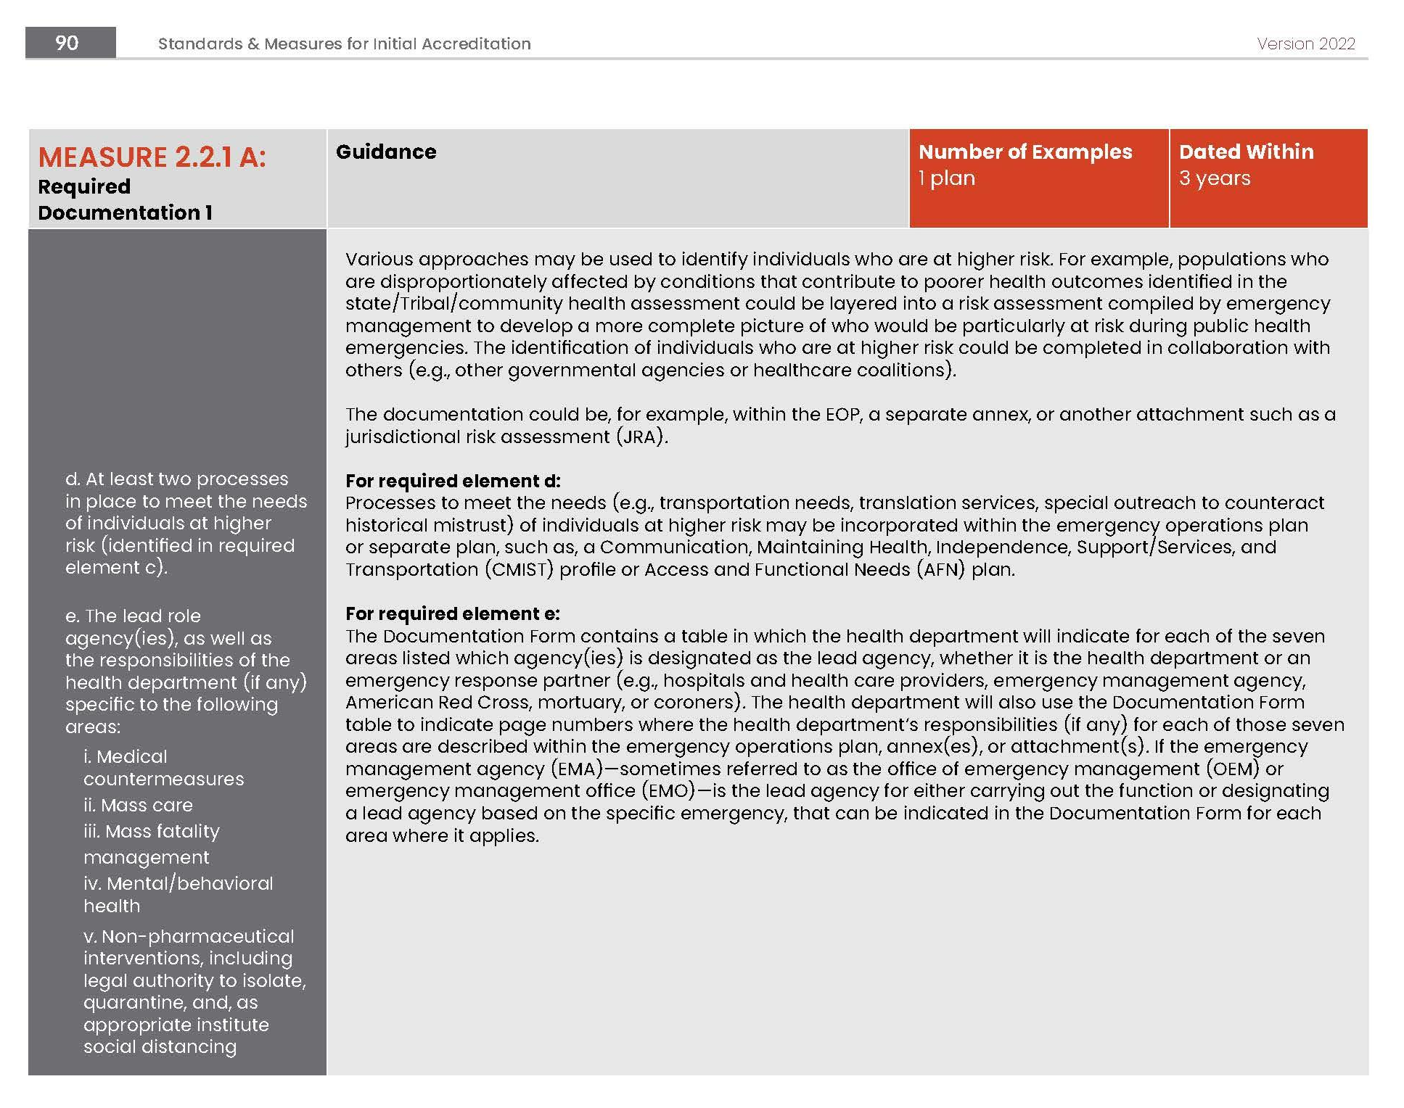

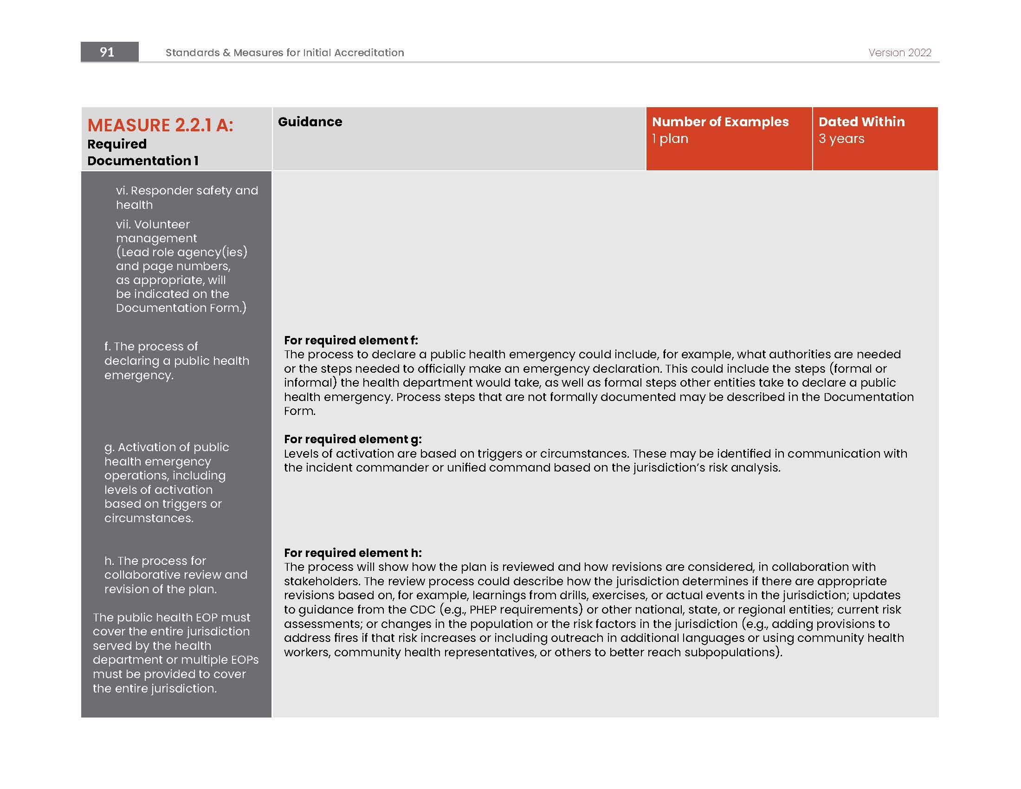

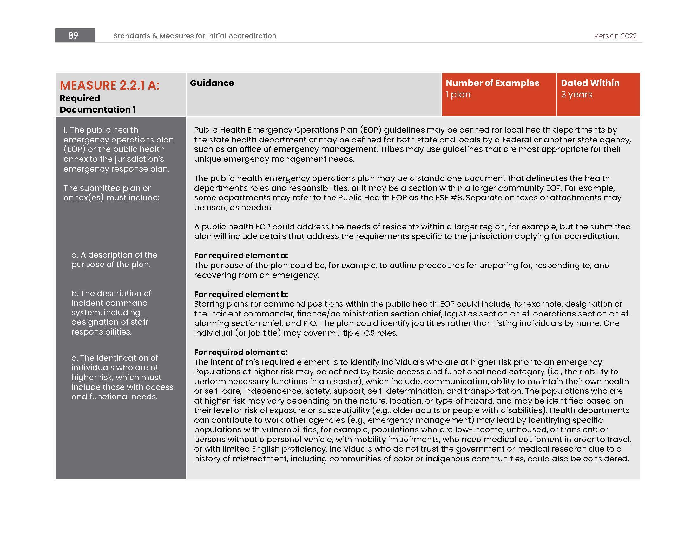

Appendix G

MRC REGION 4AB REQUEST FOR ASSISTANCE

Requesting Agency Information | Name of Agency Here
Date of Request
Requestor’s name
Requestor’s telephone
Requestor’s email
Date/Time for request response
Event Information | Event Name Here
Date/Time
Description of event
Address/Location:
(if Building, floor, office/room number)
Volunteer Information | Completed by requesting agency  (add roles as needed)
Will MRC volunteers deployed in a stand-alone MRC team or integrated in other town/volunteer teams. Please provide details
Volunteer Role #1 Description
Please note how many in this role
If medical, what exact skills and licenses needed
Any Volunteer Limitations?
If yes provide details
Volunteer Role #2 Description
Please note how many in this role
If medical, what exact skills and licenses needed
Any Volunteer Limitations?
If yes Provide details
Volunteer Role #3 Description
Please note how many in this role
If medical, what exact skills and licenses needed
Any Volunteer Limitations?
If yes Provide details
Volunteer Role #4 Description
Please note how many in this role
If medical, what exact skills and licenses needed
Any Volunteer Limitations?
If yes Provide details
Volunteer Role #5 Description
Please note how many in this role
If medical, what exact skills and licenses needed
Any Volunteer Limitations?
If yes Provide details
Other volunteer information as needed
Additional Resources Needed | Completed by requesting agency
Equipment provided by MRC | (MRC equipment is limited as is the ability to transport)
Additional equipment not provided by MRC or host agency
Incident/Event Command | Completed by requesting agency
Incident Commander/Event Coordinator
Point of Contact (the Individual) to whom volunteers report
Location for volunteer reporting
Phone number for contact above
Operational Details | Completed by requesting agency
Reporting check-in time:
Date/time/duration of shift(s)
Indoor or outdoor work?
Meals needed or provided
Parking instructions
Directions
MRC Leadership Information | To be completed by MRC Unit Coordinator
MRC person dispatching volunteers
Phone contact for above
Email for contact above

Appendix H

TEMPLATE INSTRUCTIONS
The Region 4AB Public Health Emergency Preparedness Coalition has developed a template for local jurisdictions to create a customized All-Hazards Emergency Response Framework. This document meets the requirements set forth by the Massachusetts Department of Public Health.
This template is only a suggestion and can be reformatted; you may add/change/delete content or use provided content to enhance any existing plans you may already have. In general, any sections or content that is not relevant to your organization/jurisdiction can be updated or deleted.
Note: this plan is only a template and must be reviewed and edited
with content specific to your organization/jurisdiction before finalizing.
Overarching Document Guidance:
- It is suggested that you do not develop this plan “in a bubble” – engage key internal and external stakeholders to provide information and feedback. Consider speaking with your jurisdiction’s Emergency Management point of contact; identify if this plan should be referenced in CEMP.
- Any text that is highlighted yellow should be reviewed and organization/jurisdiction names and/or information should be added here. Remove highlight once information is customized.
- Delete any content that is not applicable to your jurisdiction. Add any additional information you think is important.
- After making final edits, we suggest running spellcheck on the document.
- After making final edits, we suggest right-clicking each table of contents and selecting “update table” to ensure page numbers and section headers are updated.
- Once all final edits are completed, document the date and edits in the Record of Changes. It is also suggested that you provide this plan to internal stakeholders for final review prior to approval.
- You may complete this Appendix H: Template Instructions after customizing the document.

https://www.mass.gov/lists/infectious-disease-reporting-and-regulations-for-health-care-providers-and-laboratories
https://www.mass.gov/state-public-health-laboratory-services
https://www.maven-help.maventrainingsite.com/
https://www.mass.gov/lists/infectious-disease-data-reports-and-requests

